Default Report  
*Convergence_Exp_1*  
**April 23rd 2022, 1:28 pm CEST**

**consent - We invite you to participate in a scientific experiment. Participation requires that you give your informed consent. Before proceeding, please consider the following information:
The survey will take about 5 minutes to complete.
There are no risks involved in this study.
You will be paid for your participation at the posted rate (provided that you complete the whole study, including demographic questions).
Your individual privacy will be maintained in all published and written data resulting from the study.
Participation in this research study is voluntary. You may choose not to participate.
By ticking the box below, and proceeding to the study task you certify that you have read this form, and agreed to participate in accordance with the above conditions.**

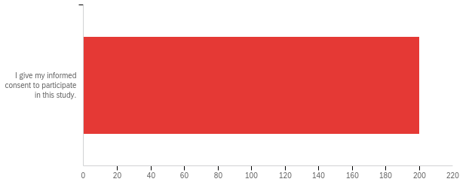

|  |  |  |  |  |  |  |  |
| --- | --- | --- | --- | --- | --- | --- | --- |
| # | Field | Minimum | Maximum | Mean | Std Deviation | Variance | Count |
| 1 | We invite you to participate in a scientific experiment. Participation requires that you give your informed consent. Before proceeding, please consider the following information: The survey will take about 5 minutes to complete. There are no risks involved in this study. You will be paid for your participation at the posted rate (provided that you complete the whole study, including demographic questions). Your individual privacy will be maintained in all published and written data resulting from the study. Participation in this research study is voluntary. You may choose not to participate. By ticking the box below, and proceeding to the study task you certify that you have read this form, and agreed to participate in accordance with the above conditions. | 1.00 | 1.00 | 1.00 | 0.00 | 0.00 | 200 |

|  |  |  |  |
| --- | --- | --- | --- |
| # | Answer | % | Count |
| 1 | I give my informed consent to participate in this study. | 100.00% | 200 |
|  | Total | 100% | 200 |

**attention - Imagine you are playing video games with a friend and at some point your friend says:
“I don’t want to play this game anymore! To make sure that you read the instructions, please write the three following words "I pay attention" in the box below. I really dislike this game, it's the most overrated game ever.”
Do you agree with your friend?**

|  |
| --- |
| Imagine you are playing video games with a friend and at some point your friend says: “I don’t want to play this game anymore! To make sure that you read the instructions, please write the three following words "I pay attention" in the box below. I really dislike this game, it's the most overrated game ever.” Do you agree with your friend? |
| i pay attention |
| I pay attention |
| I pay attention |
| I pay attention |
| I pay attention |
| I PAY ATTENTION |
| I pay attention |
| i pay attention |
| I pay attention |
| I pay attention |
| I pay attention |
| I pay attention |
| I pay attention |
| I pay attention |
| I pay attention |
| I pay attention |
| I pay attention |
| I pay attention |
| I pay attention |
| I pay attention |
| I pay attention |
| I pay attention |
| I pay attention |
| I pay attention |
| I pay attention |
| I pay attention |
| I pay attention |
| I pay attention |
| i pay attention |
| I pay attention |
| I pay attention |
| I pay attention |
| I pay attention |
| I pay attention |
| I pay attention |
| I pay attention |
| I pay attention |
| I pay attention |
| I pay attention |
| I pay attention |
| I pay attention |
| I pay attention |
| I pay attention |
| I pay attention |
| I pay attention |
| I pay attention |
| I pay attention |
| I pay attention |
| I pay attention |
| I pay attention |
| I pay attention |
| I pay attention |
| I pay attention |
| I pay attention |
| I pay attention |
| I pay attention |
| I pay attention |
| I pat attention |
| I pay attention |
| I pay attention |
| I pay attention |
| I pay attention |
| I pay attention |
| I pay attention |
| I pay attention |
| I pay attention |
| I pay attention |
| "i pay attention" |
| I pay attention |
| I pay attention |
| I pay attention |
| I pay attention |
| I pay attention |
| I pay attention |
| I pay attention |
| I pay attention |
| I pay attention |
| I pay attention |
| I pay attention |
| I pay attention |
| I pay attention |
| I pay attention |
| I pay attention |
| I pay attention |
| i pay attention |
| I pay attention |
| I pay attention |
| I pay attention |
| I pay attention |
| I pay attention |
| I pay attention |
| I pay attention |
| I pay attention |
| I pay attention |
| I pay attention |
| I pay attention |
| I pay attention |
| I pay attention |
| i pay attention |
| I pay attention |
| I pay attention |
| I pay attention |
| I pay attention |
| I pay attention |
| I pay attention |
| I pay attention |
| I pay attention |
| I pay attention |
| I pay attention |
| I pay attention |
| I pay attention |
| I pay attention |
| I pay attention |
| I pay attention |
| I pay attention |
| I pay attention |
| I pay attention |
| I pay attention |
| I pay attention |
| I pay attention |
| I pay attention |
| I pay attention |
| I pay attention |
| I pay attention |
| I pay attention |
| I pay attention |
| I pay attention |
| I pay attention |
| I pay attention |
| I pay attention |
| I pay attention |
| I pay attention |
| I pay attention |
| I pay attention |
| I pay attention |
| I pay attention |
| I pay attention |
| I pay attention |
| I pay attention |
| I pay attention |
| I pay attention |
| I pay attention |
| I pay attention |
| I pay attention |
| I pay attention |
| I pay attention |
| I pay attention |
| I pay attention |
| I pay attention |
| I pay attention |
| I pay attention |
| I pay attention |
| I pay attention |
| I pay attention |
| I pay attention |
| I pay attention |
| I pay attention |
| I pay attention |
| I pay attention |
| I pay attention |
| I pay attention |
| I pay attention |
| I pay attention |
| I pay attention |
| I pay attention |
| I pay attention. |
| I pay attention |
| I pay attention |
| I pay attention. |
| I pay attention |
| I pay attention |
| I pay attention |
| I pay attention |
| I pay attention |
| I pay attention |
| I pay attention |
| I pay attention |
| I pay attention |
| I pay attention |
| I pay attention |
| I pay attention |
| I pay attention |
| I pay attention |
| I PAY ATTENTION |
| I pay attention |
| i pay attention |
| I pay attention |
| I pay attention |
| i pay attention |
| I pay attention |
| I pay attention |
| I pay attention |
| I pay attention |
| I pay attention |
| I pay attention |
| I pay attention |
| I pay attention |
| I pay attention |
| I pay attention |
| I pay attention |

**conv_large_guess_a - What would you guess is the correct answer, if there is one?**

|  |  |  |  |  |  |  |  |
| --- | --- | --- | --- | --- | --- | --- | --- |
| # | Field | Minimum | Maximum | Mean | Std Deviation | Variance | Count |
| 1 | Click to write Choice 1 | 1380.00 | 1901.00 | 1532.30 | 53.68 | 2882.03 | 67 |

**conv_large_conf_a - How confident are you that this answer is at least approximately correct?**

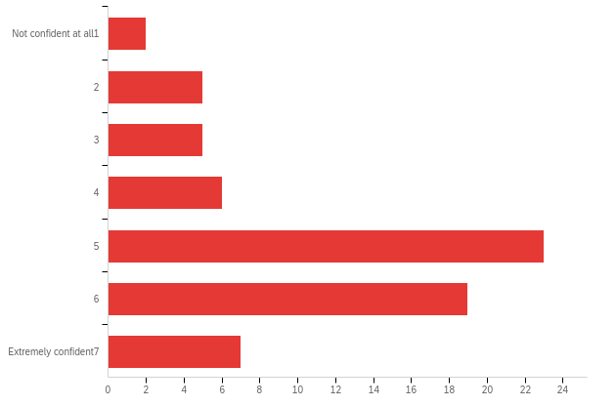

|  |  |  |  |  |  |  |  |
| --- | --- | --- | --- | --- | --- | --- | --- |
| # | Field | Minimum | Maximum | Mean | Std Deviation | Variance | Count |
| 1 | How confident are you that this answer is at least approximately correct? | 1.00 | 8.00 | 5.01 | 1.66 | 2.76 | 67 |

|  |  |  |  |
| --- | --- | --- | --- |
| # | Answer | % | Count |
| 1 | Not confident at all 1 | 2.99% | 2 |
| 2 | 2 | 7.46% | 5 |
| 3 | 3 | 7.46% | 5 |
| 4 | 4 | 8.96% | 6 |
| 5 | 5 | 34.33% | 23 |
| 6 | 6 | 28.36% | 19 |
| 8 | Extremely confident 7 | 10.45% | 7 |
|  | Total | 100% | 67 |

**conv_large_comp_a - On average, how good do you think these players are at the game?**

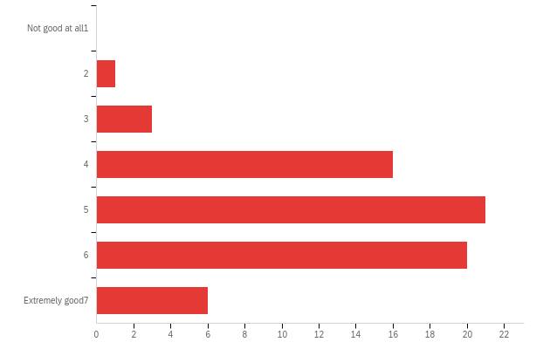

|  |  |  |  |  |  |  |  |
| --- | --- | --- | --- | --- | --- | --- | --- |
| # | Field | Minimum | Maximum | Mean | Std Deviation | Variance | Count |
| 1 | On average, how good do you think these players are at the game? | 2.00 | 8.00 | 5.19 | 1.27 | 1.62 | 67 |

|  |  |  |  |
| --- | --- | --- | --- |
| # | Answer | % | Count |
| 1 | Not good at all 1 | 0.00% | 0 |
| 2 | 2 | 1.49% | 1 |
| 3 | 3 | 4.48% | 3 |
| 4 | 4 | 23.88% | 16 |
| 5 | 5 | 31.34% | 21 |
| 6 | 6 | 29.85% | 20 |
| 8 | Extremely good 7 | 8.96% | 6 |
|  | Total | 100% | 67 |

**conv_large_guess_b - What would you guess is the correct answer, if there is one?**

|  |  |  |  |  |  |  |  |
| --- | --- | --- | --- | --- | --- | --- | --- |
| # | Field | Minimum | Maximum | Mean | Std Deviation | Variance | Count |
| 1 | 1 | 1004.00 | 1365.00 | 1303.61 | 43.94 | 1930.86 | 67 |

**conv_large_conf_b - How confident are you that this answer is at least approximately correct?**

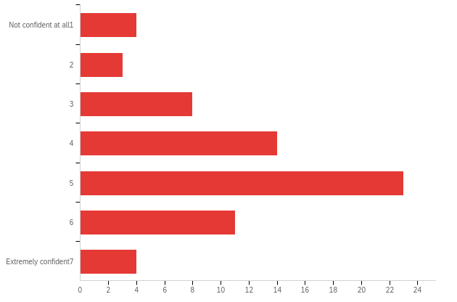

|  |  |  |  |  |  |  |  |
| --- | --- | --- | --- | --- | --- | --- | --- |
| # | Field | Minimum | Maximum | Mean | Std Deviation | Variance | Count |
| 1 | How confident are you that this answer is at least approximately correct? | 1.00 | 8.00 | 4.52 | 1.59 | 2.52 | 67 |

|  |  |  |  |
| --- | --- | --- | --- |
| # | Answer | % | Count |
| 1 | Not confident at all 1 | 5.97% | 4 |
| 2 | 2 | 4.48% | 3 |
| 3 | 3 | 11.94% | 8 |
| 4 | 4 | 20.90% | 14 |
| 5 | 5 | 34.33% | 23 |
| 6 | 6 | 16.42% | 11 |
| 8 | Extremely confident 7 | 5.97% | 4 |
|  | Total | 100% | 67 |

**conv_large_comp_b - On average, how good do you think these players are at the game?**

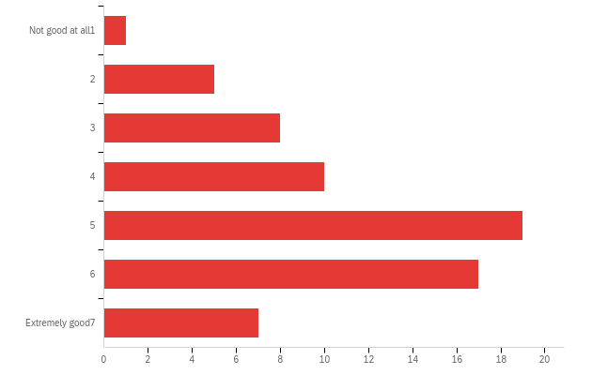

|  |  |  |  |  |  |  |  |
| --- | --- | --- | --- | --- | --- | --- | --- |
| # | Field | Minimum | Maximum | Mean | Std Deviation | Variance | Count |
| 1 | On average, how good do you think these players are at the game? | 1.00 | 8.00 | 4.90 | 1.65 | 2.72 | 67 |

|  |  |  |  |
| --- | --- | --- | --- |
| # | Answer | % | Count |
| 1 | Not good at all 1 | 1.49% | 1 |
| 2 | 2 | 7.46% | 5 |
| 3 | 3 | 11.94% | 8 |
| 4 | 4 | 14.93% | 10 |
| 5 | 5 | 28.36% | 19 |
| 6 | 6 | 25.37% | 17 |
| 8 | Extremely good 7 | 10.45% | 7 |
|  | Total | 100% | 67 |

**conv_small_guess_a - What would you guess is the correct answer, if there is one?**

|  |  |  |  |  |  |  |  |
| --- | --- | --- | --- | --- | --- | --- | --- |
| # | Field | Minimum | Maximum | Mean | Std Deviation | Variance | Count |
| 1 | 1 | 1310.00 | 1712.00 | 1630.27 | 46.70 | 2180.82 | 67 |

**conv_small_conf_a - How confident are you that this answer is at least approximately correct?**

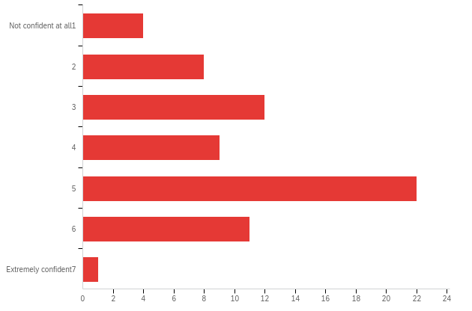

|  |  |  |  |  |  |  |  |
| --- | --- | --- | --- | --- | --- | --- | --- |
| # | Field | Minimum | Maximum | Mean | Std Deviation | Variance | Count |
| 1 | How confident are you that this answer is at least approximately correct? | 1.00 | 8.00 | 4.12 | 1.55 | 2.40 | 67 |

|  |  |  |  |
| --- | --- | --- | --- |
| # | Answer | % | Count |
| 1 | Not confident at all 1 | 5.97% | 4 |
| 2 | 2 | 11.94% | 8 |
| 3 | 3 | 17.91% | 12 |
| 4 | 4 | 13.43% | 9 |
| 5 | 5 | 32.84% | 22 |
| 6 | 6 | 16.42% | 11 |
| 8 | Extremely confident 7 | 1.49% | 1 |
|  | Total | 100% | 67 |

**conv_small_comp_a - On average, how good do you think these players are at the game?**

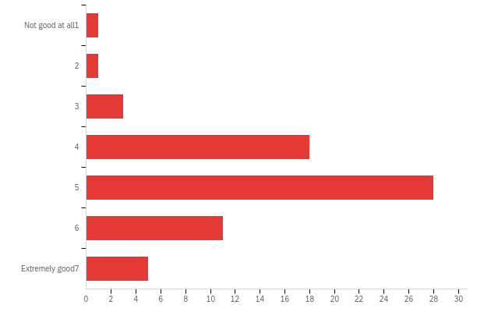

|  |  |  |  |  |  |  |  |
| --- | --- | --- | --- | --- | --- | --- | --- |
| # | Field | Minimum | Maximum | Mean | Std Deviation | Variance | Count |
| 1 | On average, how good do you think these players are at the game? | 1.00 | 8.00 | 4.93 | 1.28 | 1.65 | 67 |

|  |  |  |  |
| --- | --- | --- | --- |
| # | Answer | % | Count |
| 1 | Not good at all 1 | 1.49% | 1 |
| 2 | 2 | 1.49% | 1 |
| 3 | 3 | 4.48% | 3 |
| 4 | 4 | 26.87% | 18 |
| 5 | 5 | 41.79% | 28 |
| 6 | 6 | 16.42% | 11 |
| 8 | Extremely good 7 | 7.46% | 5 |
|  | Total | 100% | 67 |

**conv_small_guess_b - What would you guess is the correct answer, if there is one?**

|  |  |  |  |  |  |  |  |
| --- | --- | --- | --- | --- | --- | --- | --- |
| # | Field | Minimum | Maximum | Mean | Std Deviation | Variance | Count |
| 1 | 1 | 1010.00 | 1487.00 | 1413.16 | 55.33 | 3061.06 | 67 |

**conv_small_conf_b - How confident are you that this answer is at least approximately correct?**

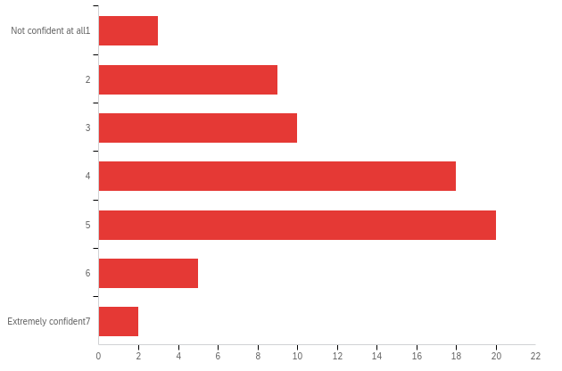

|  |  |  |  |  |  |  |  |
| --- | --- | --- | --- | --- | --- | --- | --- |
| # | Field | Minimum | Maximum | Mean | Std Deviation | Variance | Count |
| 1 | How confident are you that this answer is at least approximately correct? | 1.00 | 8.00 | 4.01 | 1.47 | 2.16 | 67 |

|  |  |  |  |
| --- | --- | --- | --- |
| # | Answer | % | Count |
| 1 | Not confident at all 1 | 4.48% | 3 |
| 2 | 2 | 13.43% | 9 |
| 3 | 3 | 14.93% | 10 |
| 4 | 4 | 26.87% | 18 |
| 5 | 5 | 29.85% | 20 |
| 6 | 6 | 7.46% | 5 |
| 8 | Extremely confident 7 | 2.99% | 2 |
|  | Total | 100% | 67 |

**conv_small_comp_b - On average, how good do you think these players are at the game?**

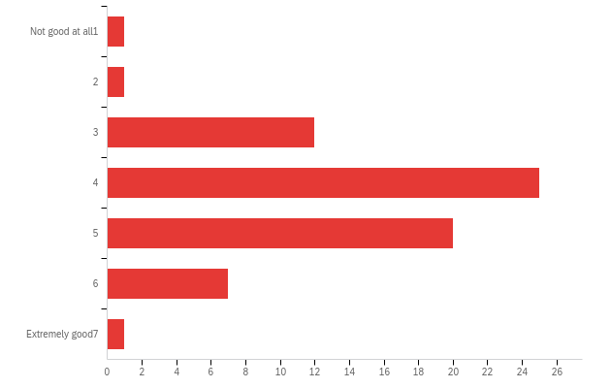

|  |  |  |  |  |  |  |  |
| --- | --- | --- | --- | --- | --- | --- | --- |
| # | Field | Minimum | Maximum | Mean | Std Deviation | Variance | Count |
| 1 | On average, how good do you think these players are at the game? | 1.00 | 8.00 | 4.31 | 1.11 | 1.23 | 67 |

|  |  |  |  |
| --- | --- | --- | --- |
| # | Answer | % | Count |
| 1 | Not good at all 1 | 1.49% | 1 |
| 2 | 2 | 1.49% | 1 |
| 3 | 3 | 17.91% | 12 |
| 4 | 4 | 37.31% | 25 |
| 5 | 5 | 29.85% | 20 |
| 6 | 6 | 10.45% | 7 |
| 8 | Extremely good 7 | 1.49% | 1 |
|  | Total | 100% | 67 |

**noconv_large_guess_a - What would you guess is the correct answer, if there is one?**

|  |  |  |  |  |  |  |  |
| --- | --- | --- | --- | --- | --- | --- | --- |
| # | Field | Minimum | Maximum | Mean | Std Deviation | Variance | Count |
| 1 | 1 | 1158.00 | 1737.00 | 1337.66 | 84.70 | 7173.81 | 67 |

**noconv_large_conf_a - How confident are you that this answer is at least approximately correct?**

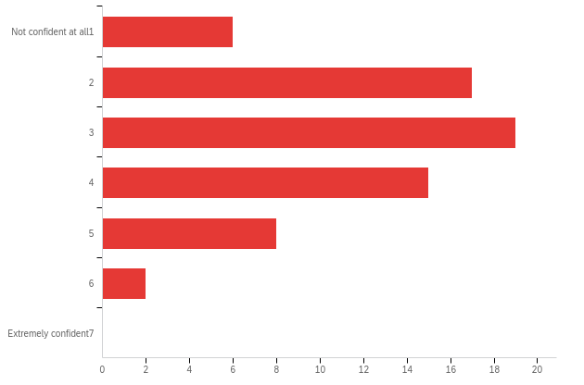

|  |  |  |  |  |  |  |  |
| --- | --- | --- | --- | --- | --- | --- | --- |
| # | Field | Minimum | Maximum | Mean | Std Deviation | Variance | Count |
| 1 | How confident are you that this answer is at least approximately correct? | 1.00 | 6.00 | 3.12 | 1.25 | 1.57 | 67 |

|  |  |  |  |
| --- | --- | --- | --- |
| # | Answer | % | Count |
| 1 | Not confident at all 1 | 8.96% | 6 |
| 2 | 2 | 25.37% | 17 |
| 3 | 3 | 28.36% | 19 |
| 4 | 4 | 22.39% | 15 |
| 5 | 5 | 11.94% | 8 |
| 6 | 6 | 2.99% | 2 |
| 8 | Extremely confident 7 | 0.00% | 0 |
|  | Total | 100% | 67 |

**noconv_large_comp_a - On average, how good do you think these players are at the game?**

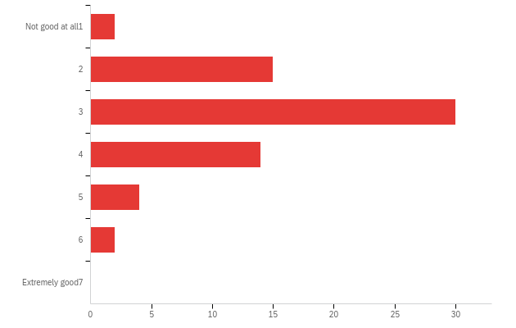

|  |  |  |  |  |  |  |  |
| --- | --- | --- | --- | --- | --- | --- | --- |
| # | Field | Minimum | Maximum | Mean | Std Deviation | Variance | Count |
| 1 | On average, how good do you think these players are at the game? | 1.00 | 6.00 | 3.13 | 1.02 | 1.04 | 67 |

|  |  |  |  |
| --- | --- | --- | --- |
| # | Answer | % | Count |
| 1 | Not good at all 1 | 2.99% | 2 |
| 2 | 2 | 22.39% | 15 |
| 3 | 3 | 44.78% | 30 |
| 4 | 4 | 20.90% | 14 |
| 5 | 5 | 5.97% | 4 |
| 6 | 6 | 2.99% | 2 |
| 8 | Extremely good 7 | 0.00% | 0 |
|  | Total | 100% | 67 |

**noconv_large_guess_b - What would you guess is the correct answer, if there is one?**

|  |  |  |  |  |  |  |  |
| --- | --- | --- | --- | --- | --- | --- | --- |
| # | Field | Minimum | Maximum | Mean | Std Deviation | Variance | Count |
| 1 | 1 | 1482.00 | 1755.00 | 1609.33 | 63.18 | 3992.01 | 67 |

**noconv_large_conf_b - How confident are you that this answer is at least approximately correct?**

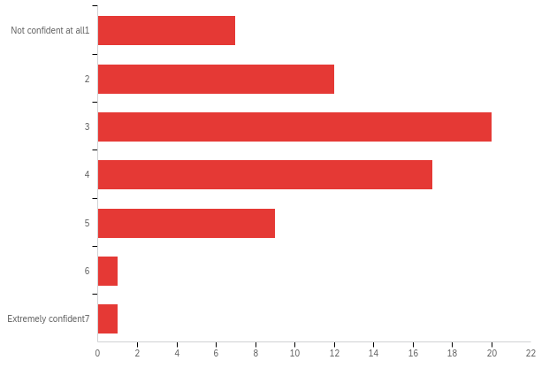

|  |  |  |  |  |  |  |  |
| --- | --- | --- | --- | --- | --- | --- | --- |
| # | Field | Minimum | Maximum | Mean | Std Deviation | Variance | Count |
| 1 | How confident are you that this answer is at least approximately correct? | 1.00 | 8.00 | 3.25 | 1.35 | 1.83 | 67 |

|  |  |  |  |
| --- | --- | --- | --- |
| # | Answer | % | Count |
| 1 | Not confident at all 1 | 10.45% | 7 |
| 2 | 2 | 17.91% | 12 |
| 3 | 3 | 29.85% | 20 |
| 4 | 4 | 25.37% | 17 |
| 5 | 5 | 13.43% | 9 |
| 6 | 6 | 1.49% | 1 |
| 8 | Extremely confident 7 | 1.49% | 1 |
|  | Total | 100% | 67 |

**noconv_large_comp_b - On average, how good do you think these players are at the game?**

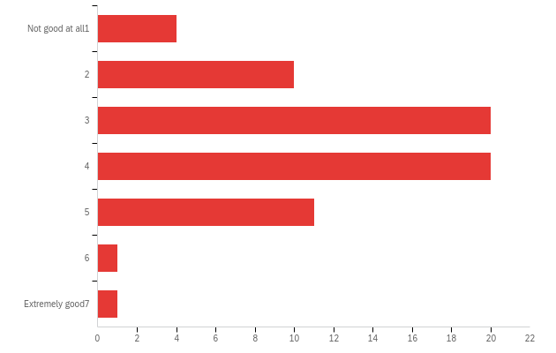

|  |  |  |  |  |  |  |  |
| --- | --- | --- | --- | --- | --- | --- | --- |
| # | Field | Minimum | Maximum | Mean | Std Deviation | Variance | Count |
| 1 | On average, how good do you think these players are at the game? | 1.00 | 8.00 | 3.48 | 1.27 | 1.62 | 67 |

|  |  |  |  |
| --- | --- | --- | --- |
| # | Answer | % | Count |
| 1 | Not good at all 1 | 5.97% | 4 |
| 2 | 2 | 14.93% | 10 |
| 3 | 3 | 29.85% | 20 |
| 4 | 4 | 29.85% | 20 |
| 5 | 5 | 16.42% | 11 |
| 6 | 6 | 1.49% | 1 |
| 8 | Extremely good 7 | 1.49% | 1 |
|  | Total | 100% | 67 |

**noconv_small_guess_a - What would you guess is the correct answer, if there is one?**

|  |  |  |  |  |  |  |  |
| --- | --- | --- | --- | --- | --- | --- | --- |
| # | Field | Minimum | Maximum | Mean | Std Deviation | Variance | Count |
| 1 | 1 | 1237.00 | 1765.00 | 1373.03 | 88.05 | 7752.09 | 67 |

**noconv_small_conf_a - How confident are you that this answer is at least approximately correct?**

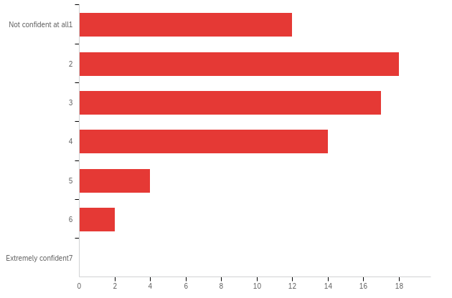

|  |  |  |  |  |  |  |  |
| --- | --- | --- | --- | --- | --- | --- | --- |
| # | Field | Minimum | Maximum | Mean | Std Deviation | Variance | Count |
| 1 | How confident are you that this answer is at least approximately correct? | 1.00 | 6.00 | 2.79 | 1.29 | 1.66 | 67 |

|  |  |  |  |
| --- | --- | --- | --- |
| # | Answer | % | Count |
| 1 | Not confident at all 1 | 17.91% | 12 |
| 2 | 2 | 26.87% | 18 |
| 3 | 3 | 25.37% | 17 |
| 4 | 4 | 20.90% | 14 |
| 5 | 5 | 5.97% | 4 |
| 6 | 6 | 2.99% | 2 |
| 8 | Extremely confident 7 | 0.00% | 0 |
|  | Total | 100% | 67 |

**noconv_small_comp_a - On average, how good do you think these players are at the game?**

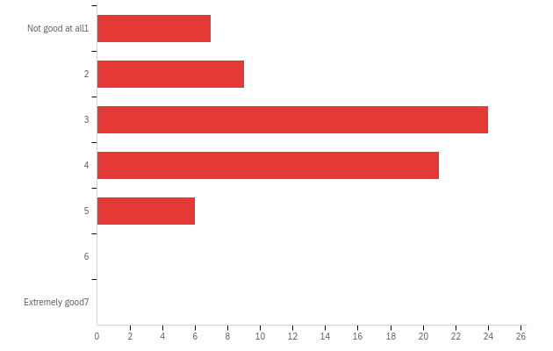

|  |  |  |  |  |  |  |  |
| --- | --- | --- | --- | --- | --- | --- | --- |
| # | Field | Minimum | Maximum | Mean | Std Deviation | Variance | Count |
| 1 | On average, how good do you think these players are at the game? | 1.00 | 5.00 | 3.15 | 1.10 | 1.20 | 67 |

|  |  |  |  |
| --- | --- | --- | --- |
| # | Answer | % | Count |
| 1 | Not good at all 1 | 10.45% | 7 |
| 2 | 2 | 13.43% | 9 |
| 3 | 3 | 35.82% | 24 |
| 4 | 4 | 31.34% | 21 |
| 5 | 5 | 8.96% | 6 |
| 6 | 6 | 0.00% | 0 |
| 8 | Extremely good 7 | 0.00% | 0 |
|  | Total | 100% | 67 |

**noconv_small_guess_b - What would you guess is the correct answer, if there is one?**

|  |  |  |  |  |  |  |  |
| --- | --- | --- | --- | --- | --- | --- | --- |
| # | Field | Minimum | Maximum | Mean | Std Deviation | Variance | Count |
| 1 | 1 | 1394.00 | 2000.00 | 1611.91 | 76.87 | 5909.39 | 67 |

**noconv_small_conf_b - How confident are you that this answer is at least approximately correct?**

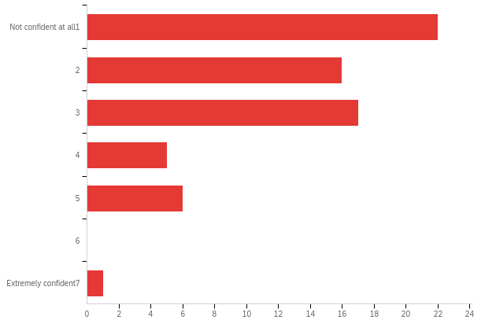

|  |  |  |  |  |  |  |  |
| --- | --- | --- | --- | --- | --- | --- | --- |
| # | Field | Minimum | Maximum | Mean | Std Deviation | Variance | Count |
| 1 | How confident are you that this answer is at least approximately correct? | 1.00 | 8.00 | 2.43 | 1.43 | 2.04 | 67 |

|  |  |  |  |
| --- | --- | --- | --- |
| # | Answer | % | Count |
| 1 | Not confident at all 1 | 32.84% | 22 |
| 2 | 2 | 23.88% | 16 |
| 3 | 3 | 25.37% | 17 |
| 4 | 4 | 7.46% | 5 |
| 5 | 5 | 8.96% | 6 |
| 6 | 6 | 0.00% | 0 |
| 8 | Extremely confident 7 | 1.49% | 1 |
|  | Total | 100% | 67 |

**noconv_small_comp_b - On average, how good do you think these players are at the game?**

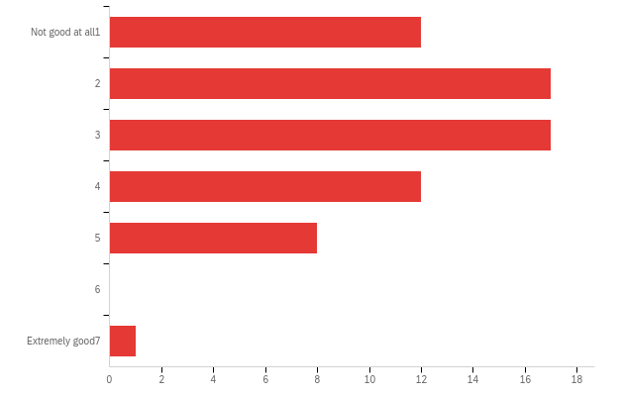

|  |  |  |  |  |  |  |  |
| --- | --- | --- | --- | --- | --- | --- | --- |
| # | Field | Minimum | Maximum | Mean | Std Deviation | Variance | Count |
| 1 | On average, how good do you think these players are at the game? | 1.00 | 8.00 | 2.88 | 1.41 | 1.99 | 67 |

|  |  |  |  |
| --- | --- | --- | --- |
| # | Answer | % | Count |
| 1 | Not good at all 1 | 17.91% | 12 |
| 2 | 2 | 25.37% | 17 |
| 3 | 3 | 25.37% | 17 |
| 4 | 4 | 17.91% | 12 |
| 5 | 5 | 11.94% | 8 |
| 6 | 6 | 0.00% | 0 |
| 8 | Extremely good 7 | 1.49% | 1 |
|  | Total | 100% | 67 |

**conv_large_guess_a - What would you guess is the correct answer, if there is one?**

|  |  |  |  |  |  |  |  |
| --- | --- | --- | --- | --- | --- | --- | --- |
| # | Field | Minimum | Maximum | Mean | Std Deviation | Variance | Count |
| 1 | 1 | 1493.00 | 1663.00 | 1540.26 | 32.37 | 1047.89 | 66 |

**conv_large_conf_a - How confident are you that this answer is at least approximately correct?**

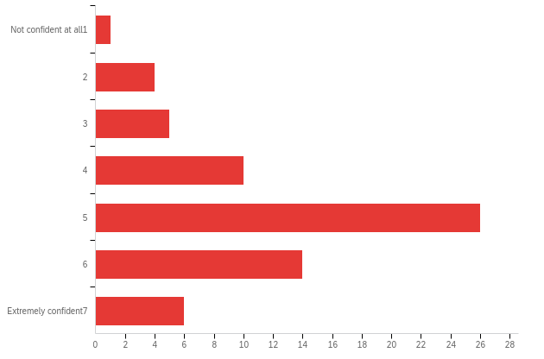

|  |  |  |  |  |  |  |  |
| --- | --- | --- | --- | --- | --- | --- | --- |
| # | Field | Minimum | Maximum | Mean | Std Deviation | Variance | Count |
| 1 | How confident are you that this answer is at least approximately correct? | 1.00 | 8.00 | 4.94 | 1.51 | 2.27 | 66 |

|  |  |  |  |
| --- | --- | --- | --- |
| # | Answer | % | Count |
| 1 | Not confident at all 1 | 1.52% | 1 |
| 2 | 2 | 6.06% | 4 |
| 3 | 3 | 7.58% | 5 |
| 4 | 4 | 15.15% | 10 |
| 5 | 5 | 39.39% | 26 |
| 6 | 6 | 21.21% | 14 |
| 8 | Extremely confident 7 | 9.09% | 6 |
|  | Total | 100% | 66 |

**conv_large_comp_a - On average, how good do you think these players are at the game?**

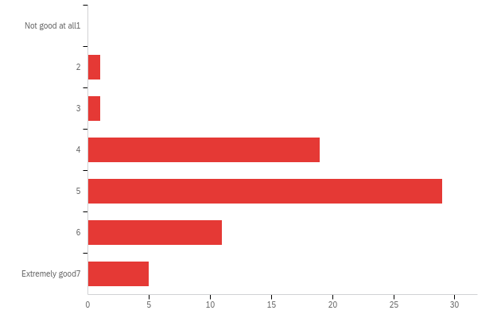

|  |  |  |  |  |  |  |  |
| --- | --- | --- | --- | --- | --- | --- | --- |
| # | Field | Minimum | Maximum | Mean | Std Deviation | Variance | Count |
| 1 | On average, how good do you think these players are at the game? | 2.00 | 8.00 | 5.03 | 1.15 | 1.33 | 66 |

|  |  |  |  |
| --- | --- | --- | --- |
| # | Answer | % | Count |
| 1 | Not good at all 1 | 0.00% | 0 |
| 2 | 2 | 1.52% | 1 |
| 3 | 3 | 1.52% | 1 |
| 4 | 4 | 28.79% | 19 |
| 5 | 5 | 43.94% | 29 |
| 6 | 6 | 16.67% | 11 |
| 8 | Extremely good 7 | 7.58% | 5 |
|  | Total | 100% | 66 |

**conv_large_guess_b - What would you guess is the correct answer, if there is one?**

|  |  |  |  |  |  |  |  |
| --- | --- | --- | --- | --- | --- | --- | --- |
| # | Field | Minimum | Maximum | Mean | Std Deviation | Variance | Count |
| 1 | 1 | 1228.00 | 1500.00 | 1377.17 | 33.14 | 1098.23 | 66 |

**conv_large_conf_b - How confident are you that this answer is at least approximately correct?**

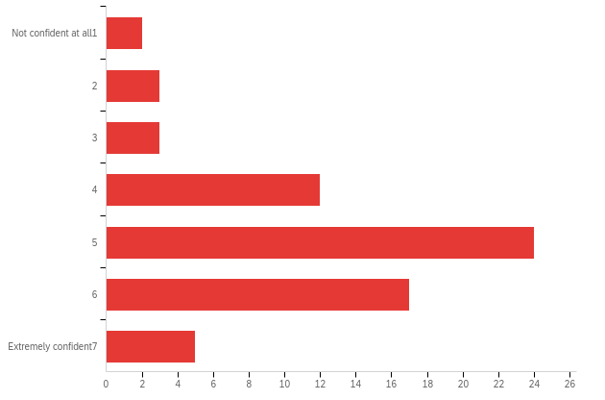

|  |  |  |  |  |  |  |  |
| --- | --- | --- | --- | --- | --- | --- | --- |
| # | Field | Minimum | Maximum | Mean | Std Deviation | Variance | Count |
| 1 | How confident are you that this answer is at least approximately correct? | 1.00 | 8.00 | 4.95 | 1.48 | 2.19 | 66 |

|  |  |  |  |
| --- | --- | --- | --- |
| # | Answer | % | Count |
| 1 | Not confident at all 1 | 3.03% | 2 |
| 2 | 2 | 4.55% | 3 |
| 3 | 3 | 4.55% | 3 |
| 4 | 4 | 18.18% | 12 |
| 5 | 5 | 36.36% | 24 |
| 6 | 6 | 25.76% | 17 |
| 8 | Extremely confident 7 | 7.58% | 5 |
|  | Total | 100% | 66 |

**conv_large_comp_b - On average, how good do you think these players are at the game?**

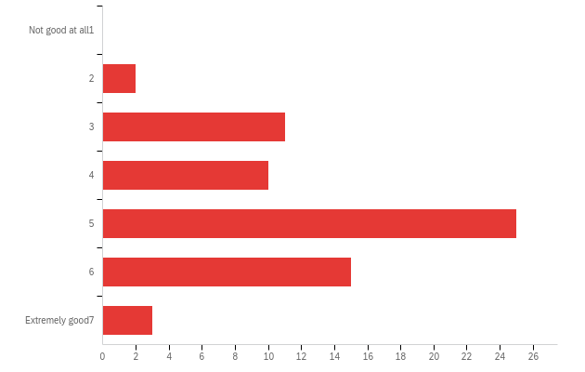

|  |  |  |  |  |  |  |  |
| --- | --- | --- | --- | --- | --- | --- | --- |
| # | Field | Minimum | Maximum | Mean | Std Deviation | Variance | Count |
| 1 | On average, how good do you think these players are at the game? | 2.00 | 8.00 | 4.79 | 1.30 | 1.68 | 66 |

|  |  |  |  |
| --- | --- | --- | --- |
| # | Answer | % | Count |
| 1 | Not good at all 1 | 0.00% | 0 |
| 2 | 2 | 3.03% | 2 |
| 3 | 3 | 16.67% | 11 |
| 4 | 4 | 15.15% | 10 |
| 5 | 5 | 37.88% | 25 |
| 6 | 6 | 22.73% | 15 |
| 8 | Extremely good 7 | 4.55% | 3 |
|  | Total | 100% | 66 |

**conv_small_guess_a - What would you guess is the correct answer, if there is one?**

|  |  |  |  |  |  |  |  |
| --- | --- | --- | --- | --- | --- | --- | --- |
| # | Field | Minimum | Maximum | Mean | Std Deviation | Variance | Count |
| 1 | 1 | 1424.00 | 1519.00 | 1476.97 | 19.77 | 390.79 | 66 |

**conv_small_conf_a - How confident are you that this answer is at least approximately correct?**

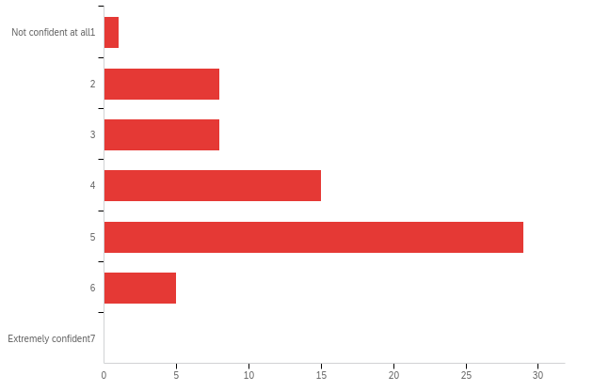

|  |  |  |  |  |  |  |  |
| --- | --- | --- | --- | --- | --- | --- | --- |
| # | Field | Minimum | Maximum | Mean | Std Deviation | Variance | Count |
| 1 | How confident are you that this answer is at least approximately correct? | 1.00 | 6.00 | 4.18 | 1.20 | 1.45 | 66 |

|  |  |  |  |
| --- | --- | --- | --- |
| # | Answer | % | Count |
| 1 | Not confident at all 1 | 1.52% | 1 |
| 2 | 2 | 12.12% | 8 |
| 3 | 3 | 12.12% | 8 |
| 4 | 4 | 22.73% | 15 |
| 5 | 5 | 43.94% | 29 |
| 6 | 6 | 7.58% | 5 |
| 8 | Extremely confident 7 | 0.00% | 0 |
|  | Total | 100% | 66 |

**conv_small_comp_a - On average, how good do you think these players are at the game?**

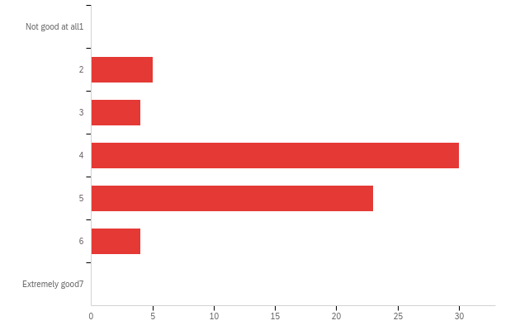

|  |  |  |  |  |  |  |  |
| --- | --- | --- | --- | --- | --- | --- | --- |
| # | Field | Minimum | Maximum | Mean | Std Deviation | Variance | Count |
| 1 | On average, how good do you think these players are at the game? | 2.00 | 6.00 | 4.26 | 0.94 | 0.89 | 66 |

|  |  |  |  |
| --- | --- | --- | --- |
| # | Answer | % | Count |
| 1 | Not good at all 1 | 0.00% | 0 |
| 2 | 2 | 7.58% | 5 |
| 3 | 3 | 6.06% | 4 |
| 4 | 4 | 45.45% | 30 |
| 5 | 5 | 34.85% | 23 |
| 6 | 6 | 6.06% | 4 |
| 8 | Extremely good 7 | 0.00% | 0 |
|  | Total | 100% | 66 |

**conv_small_guess_b - What would you guess is the correct answer, if there is one?**

|  |  |  |  |  |  |  |  |
| --- | --- | --- | --- | --- | --- | --- | --- |
| # | Field | Minimum | Maximum | Mean | Std Deviation | Variance | Count |
| 1 | 1 | 1295.00 | 1503.00 | 1336.05 | 32.34 | 1046.19 | 66 |

**conv_small_conf_b - How confident are you that this answer is at least approximately correct?**

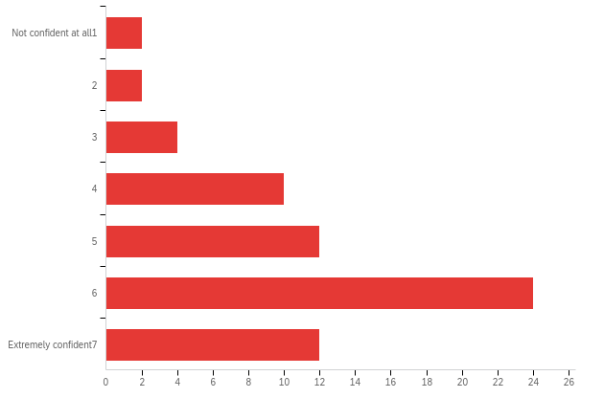

|  |  |  |  |  |  |  |  |
| --- | --- | --- | --- | --- | --- | --- | --- |
| # | Field | Minimum | Maximum | Mean | Std Deviation | Variance | Count |
| 1 | How confident are you that this answer is at least approximately correct? | 1.00 | 8.00 | 5.42 | 1.72 | 2.97 | 66 |

|  |  |  |  |
| --- | --- | --- | --- |
| # | Answer | % | Count |
| 1 | Not confident at all 1 | 3.03% | 2 |
| 2 | 2 | 3.03% | 2 |
| 3 | 3 | 6.06% | 4 |
| 4 | 4 | 15.15% | 10 |
| 5 | 5 | 18.18% | 12 |
| 6 | 6 | 36.36% | 24 |
| 8 | Extremely confident 7 | 18.18% | 12 |
|  | Total | 100% | 66 |

**conv_small_comp_b - On average, how good do you think these players are at the game?**

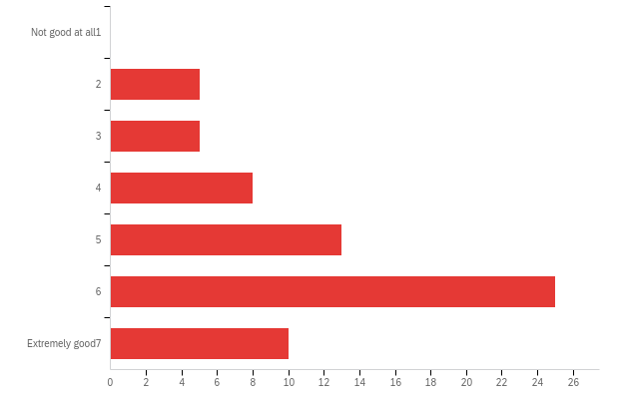

|  |  |  |  |  |  |  |  |
| --- | --- | --- | --- | --- | --- | --- | --- |
| # | Field | Minimum | Maximum | Mean | Std Deviation | Variance | Count |
| 1 | On average, how good do you think these players are at the game? | 2.00 | 8.00 | 5.33 | 1.65 | 2.74 | 66 |

|  |  |  |  |
| --- | --- | --- | --- |
| # | Answer | % | Count |
| 1 | Not good at all 1 | 0.00% | 0 |
| 2 | 2 | 7.58% | 5 |
| 3 | 3 | 7.58% | 5 |
| 4 | 4 | 12.12% | 8 |
| 5 | 5 | 19.70% | 13 |
| 6 | 6 | 37.88% | 25 |
| 8 | Extremely good 7 | 15.15% | 10 |
|  | Total | 100% | 66 |

**noconv_large_guess_a - What would you guess is the correct answer, if there is one?**

|  |  |  |  |  |  |  |  |
| --- | --- | --- | --- | --- | --- | --- | --- |
| # | Field | Minimum | Maximum | Mean | Std Deviation | Variance | Count |
| 1 | 1 | 1500.00 | 1717.00 | 1595.32 | 53.24 | 2834.64 | 66 |

**noconv_large_conf_a - How confident are you that this answer is at least approximately correct?**

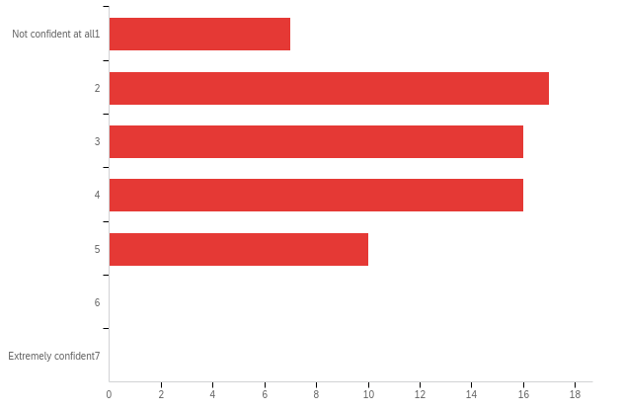

|  |  |  |  |  |  |  |  |
| --- | --- | --- | --- | --- | --- | --- | --- |
| # | Field | Minimum | Maximum | Mean | Std Deviation | Variance | Count |
| 1 | How confident are you that this answer is at least approximately correct? | 1.00 | 5.00 | 3.08 | 1.23 | 1.52 | 66 |

|  |  |  |  |
| --- | --- | --- | --- |
| # | Answer | % | Count |
| 1 | Not confident at all 1 | 10.61% | 7 |
| 2 | 2 | 25.76% | 17 |
| 3 | 3 | 24.24% | 16 |
| 4 | 4 | 24.24% | 16 |
| 5 | 5 | 15.15% | 10 |
| 6 | 6 | 0.00% | 0 |
| 8 | Extremely confident 7 | 0.00% | 0 |
|  | Total | 100% | 66 |

**noconv_large_comp_a - On average, how good do you think these players are at the game?**

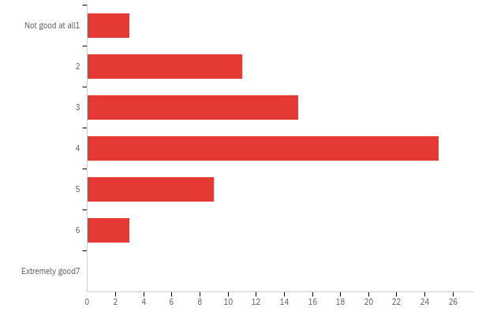

|  |  |  |  |  |  |  |  |
| --- | --- | --- | --- | --- | --- | --- | --- |
| # | Field | Minimum | Maximum | Mean | Std Deviation | Variance | Count |
| 1 | On average, how good do you think these players are at the game? | 1.00 | 6.00 | 3.53 | 1.18 | 1.40 | 66 |

|  |  |  |  |
| --- | --- | --- | --- |
| # | Answer | % | Count |
| 1 | Not good at all 1 | 4.55% | 3 |
| 2 | 2 | 16.67% | 11 |
| 3 | 3 | 22.73% | 15 |
| 4 | 4 | 37.88% | 25 |
| 5 | 5 | 13.64% | 9 |
| 6 | 6 | 4.55% | 3 |
| 8 | Extremely good 7 | 0.00% | 0 |
|  | Total | 100% | 66 |

**noconv_large_guess_b - What would you guess is the correct answer, if there is one?**

|  |  |  |  |  |  |  |  |
| --- | --- | --- | --- | --- | --- | --- | --- |
| # | Field | Minimum | Maximum | Mean | Std Deviation | Variance | Count |
| 1 | 1 | 1270.00 | 1714.00 | 1457.47 | 109.95 | 12088.37 | 66 |

**noconv_large_conf_b - How confident are you that this answer is at least approximately correct?**

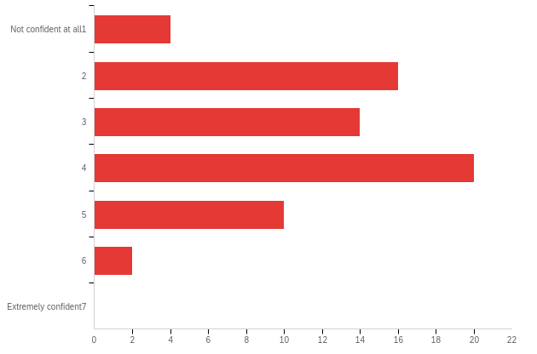

|  |  |  |  |  |  |  |  |
| --- | --- | --- | --- | --- | --- | --- | --- |
| # | Field | Minimum | Maximum | Mean | Std Deviation | Variance | Count |
| 1 | How confident are you that this answer is at least approximately correct? | 1.00 | 6.00 | 3.33 | 1.25 | 1.56 | 66 |

|  |  |  |  |
| --- | --- | --- | --- |
| # | Answer | % | Count |
| 1 | Not confident at all 1 | 6.06% | 4 |
| 2 | 2 | 24.24% | 16 |
| 3 | 3 | 21.21% | 14 |
| 4 | 4 | 30.30% | 20 |
| 5 | 5 | 15.15% | 10 |
| 6 | 6 | 3.03% | 2 |
| 8 | Extremely confident 7 | 0.00% | 0 |
|  | Total | 100% | 66 |

**noconv_large_comp_b - On average, how good do you think these players are at the game?**

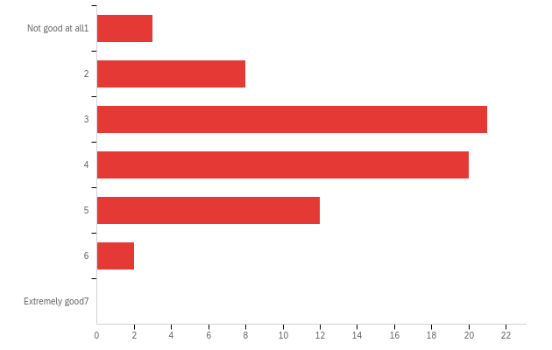

|  |  |  |  |  |  |  |  |
| --- | --- | --- | --- | --- | --- | --- | --- |
| # | Field | Minimum | Maximum | Mean | Std Deviation | Variance | Count |
| 1 | On average, how good do you think these players are at the game? | 1.00 | 6.00 | 3.55 | 1.14 | 1.31 | 66 |

|  |  |  |  |
| --- | --- | --- | --- |
| # | Answer | % | Count |
| 1 | Not good at all 1 | 4.55% | 3 |
| 2 | 2 | 12.12% | 8 |
| 3 | 3 | 31.82% | 21 |
| 4 | 4 | 30.30% | 20 |
| 5 | 5 | 18.18% | 12 |
| 6 | 6 | 3.03% | 2 |
| 8 | Extremely good 7 | 0.00% | 0 |
|  | Total | 100% | 66 |

**noconv_small_guess_a - What would you guess is the correct answer, if there is one?**

|  |  |  |  |  |  |  |  |
| --- | --- | --- | --- | --- | --- | --- | --- |
| # | Field | Minimum | Maximum | Mean | Std Deviation | Variance | Count |
| 1 | 1 | 1152.00 | 1820.00 | 1649.86 | 89.97 | 8095.21 | 66 |

**noconv_small_conf_a - How confident are you that this answer is at least approximately correct?**

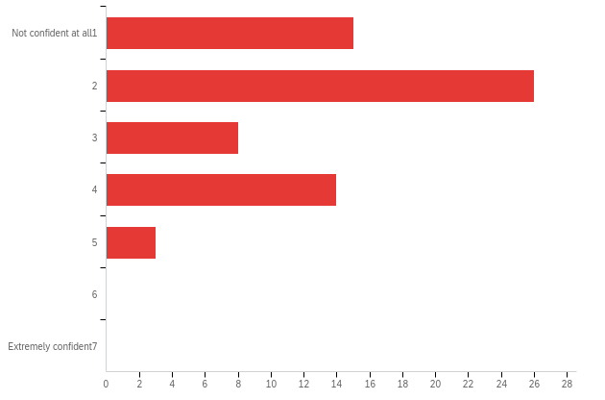

|  |  |  |  |  |  |  |  |
| --- | --- | --- | --- | --- | --- | --- | --- |
| # | Field | Minimum | Maximum | Mean | Std Deviation | Variance | Count |
| 1 | How confident are you that this answer is at least approximately correct? | 1.00 | 5.00 | 2.45 | 1.18 | 1.40 | 66 |

|  |  |  |  |
| --- | --- | --- | --- |
| # | Answer | % | Count |
| 1 | Not confident at all 1 | 22.73% | 15 |
| 2 | 2 | 39.39% | 26 |
| 3 | 3 | 12.12% | 8 |
| 4 | 4 | 21.21% | 14 |
| 5 | 5 | 4.55% | 3 |
| 6 | 6 | 0.00% | 0 |
| 8 | Extremely confident 7 | 0.00% | 0 |
|  | Total | 100% | 66 |

**noconv_small_comp_a - On average, how good do you think these players are at the game?**

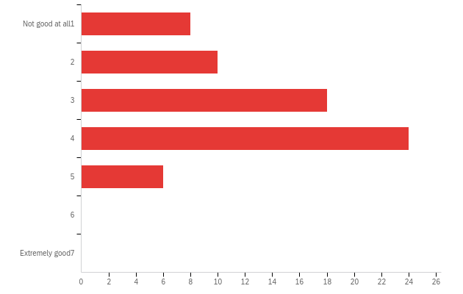

|  |  |  |  |  |  |  |  |
| --- | --- | --- | --- | --- | --- | --- | --- |
| # | Field | Minimum | Maximum | Mean | Std Deviation | Variance | Count |
| 1 | On average, how good do you think these players are at the game? | 1.00 | 5.00 | 3.15 | 1.16 | 1.34 | 66 |

|  |  |  |  |
| --- | --- | --- | --- |
| # | Answer | % | Count |
| 1 | Not good at all 1 | 12.12% | 8 |
| 2 | 2 | 15.15% | 10 |
| 3 | 3 | 27.27% | 18 |
| 4 | 4 | 36.36% | 24 |
| 5 | 5 | 9.09% | 6 |
| 6 | 6 | 0.00% | 0 |
| 8 | Extremely good 7 | 0.00% | 0 |
|  | Total | 100% | 66 |

**noconv_small_guess_b - What would you guess is the correct answer, if there is one?**

|  |  |  |  |  |  |  |  |
| --- | --- | --- | --- | --- | --- | --- | --- |
| # | Field | Minimum | Maximum | Mean | Std Deviation | Variance | Count |
| 1 | 1 | 1500.00 | 1825.00 | 1765.62 | 41.17 | 1694.72 | 66 |

**noconv_small_conf_b - How confident are you that this answer is at least approximately correct?**

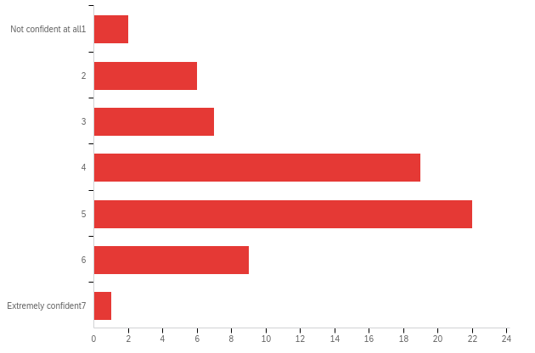

|  |  |  |  |  |  |  |  |
| --- | --- | --- | --- | --- | --- | --- | --- |
| # | Field | Minimum | Maximum | Mean | Std Deviation | Variance | Count |
| 1 | How confident are you that this answer is at least approximately correct? | 1.00 | 8.00 | 4.29 | 1.33 | 1.78 | 66 |

|  |  |  |  |
| --- | --- | --- | --- |
| # | Answer | % | Count |
| 1 | Not confident at all 1 | 3.03% | 2 |
| 2 | 2 | 9.09% | 6 |
| 3 | 3 | 10.61% | 7 |
| 4 | 4 | 28.79% | 19 |
| 5 | 5 | 33.33% | 22 |
| 6 | 6 | 13.64% | 9 |
| 8 | Extremely confident 7 | 1.52% | 1 |
|  | Total | 100% | 66 |

**noconv_small_comp_b - On average, how good do you think these players are at the game?**

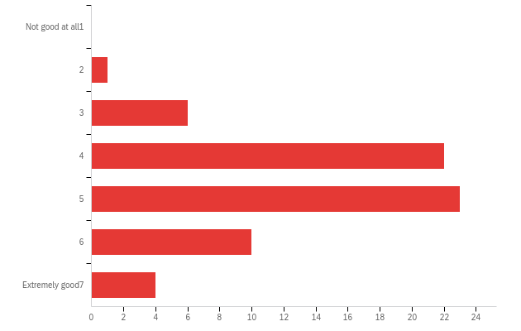

|  |  |  |  |  |  |  |  |
| --- | --- | --- | --- | --- | --- | --- | --- |
| # | Field | Minimum | Maximum | Mean | Std Deviation | Variance | Count |
| 1 | On average, how good do you think these players are at the game? | 2.00 | 8.00 | 4.77 | 1.22 | 1.48 | 66 |

|  |  |  |  |
| --- | --- | --- | --- |
| # | Answer | % | Count |
| 1 | Not good at all 1 | 0.00% | 0 |
| 2 | 2 | 1.52% | 1 |
| 3 | 3 | 9.09% | 6 |
| 4 | 4 | 33.33% | 22 |
| 5 | 5 | 34.85% | 23 |
| 6 | 6 | 15.15% | 10 |
| 8 | Extremely good 7 | 6.06% | 4 |
|  | Total | 100% | 66 |

**conv_large_guess_a - What would you guess is the correct answer, if there is one?**

|  |  |  |  |  |  |  |  |
| --- | --- | --- | --- | --- | --- | --- | --- |
| # | Field | Minimum | Maximum | Mean | Std Deviation | Variance | Count |
| 1 | 1 | 1000.00 | 1658.00 | 1381.94 | 72.50 | 5256.68 | 67 |

**conv_large_conf_a - How confident are you that this answer is at least approximately correct?**

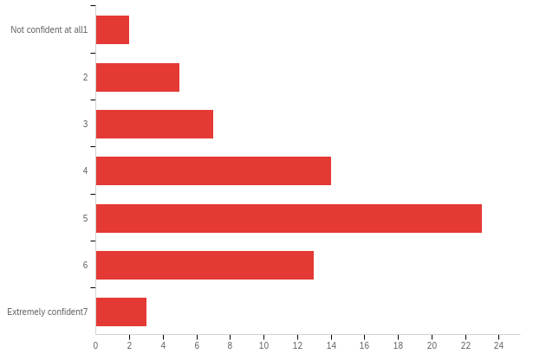

|  |  |  |  |  |  |  |  |
| --- | --- | --- | --- | --- | --- | --- | --- |
| # | Field | Minimum | Maximum | Mean | Std Deviation | Variance | Count |
| 1 | How confident are you that this answer is at least approximately correct? | 1.00 | 8.00 | 4.57 | 1.48 | 2.19 | 67 |

|  |  |  |  |
| --- | --- | --- | --- |
| # | Answer | % | Count |
| 1 | Not confident at all 1 | 2.99% | 2 |
| 2 | 2 | 7.46% | 5 |
| 3 | 3 | 10.45% | 7 |
| 4 | 4 | 20.90% | 14 |
| 5 | 5 | 34.33% | 23 |
| 6 | 6 | 19.40% | 13 |
| 8 | Extremely confident 7 | 4.48% | 3 |
|  | Total | 100% | 67 |

**conv_large_comp_a - On average, how good do you think these players are at the game?**

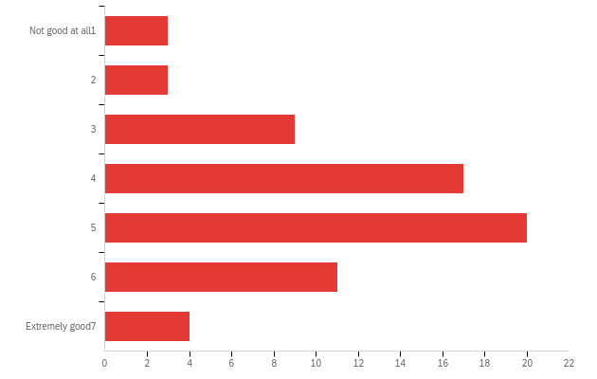

|  |  |  |  |  |  |  |  |
| --- | --- | --- | --- | --- | --- | --- | --- |
| # | Field | Minimum | Maximum | Mean | Std Deviation | Variance | Count |
| 1 | On average, how good do you think these players are at the game? | 1.00 | 8.00 | 4.51 | 1.54 | 2.37 | 67 |

|  |  |  |  |
| --- | --- | --- | --- |
| # | Answer | % | Count |
| 1 | Not good at all 1 | 4.48% | 3 |
| 2 | 2 | 4.48% | 3 |
| 3 | 3 | 13.43% | 9 |
| 4 | 4 | 25.37% | 17 |
| 5 | 5 | 29.85% | 20 |
| 6 | 6 | 16.42% | 11 |
| 8 | Extremely good 7 | 5.97% | 4 |
|  | Total | 100% | 67 |

**conv_large_guess_b - What would you guess is the correct answer, if there is one?**

|  |  |  |  |  |  |  |  |
| --- | --- | --- | --- | --- | --- | --- | --- |
| # | Field | Minimum | Maximum | Mean | Std Deviation | Variance | Count |
| 1 | 1 | 1375.00 | 1799.00 | 1684.60 | 64.50 | 4159.73 | 67 |

**conv_large_conf_b - How confident are you that this answer is at least approximately correct?**

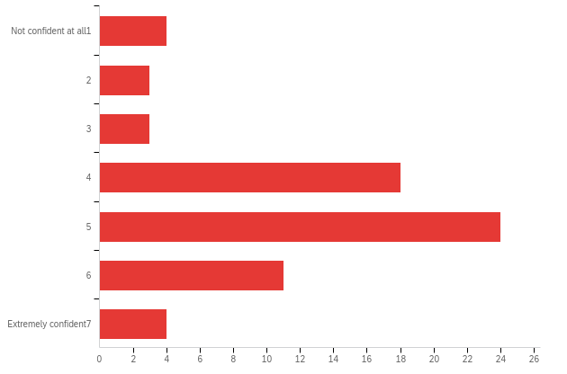

|  |  |  |  |  |  |  |  |
| --- | --- | --- | --- | --- | --- | --- | --- |
| # | Field | Minimum | Maximum | Mean | Std Deviation | Variance | Count |
| 1 | How confident are you that this answer is at least approximately correct? | 1.00 | 8.00 | 4.61 | 1.54 | 2.36 | 67 |

|  |  |  |  |
| --- | --- | --- | --- |
| # | Answer | % | Count |
| 1 | Not confident at all 1 | 5.97% | 4 |
| 2 | 2 | 4.48% | 3 |
| 3 | 3 | 4.48% | 3 |
| 4 | 4 | 26.87% | 18 |
| 5 | 5 | 35.82% | 24 |
| 6 | 6 | 16.42% | 11 |
| 8 | Extremely confident 7 | 5.97% | 4 |
|  | Total | 100% | 67 |

**conv_large_comp_b - On average, how good do you think these players are at the game?**

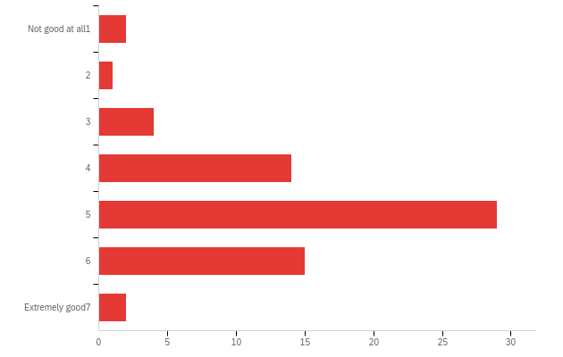

|  |  |  |  |  |  |  |  |
| --- | --- | --- | --- | --- | --- | --- | --- |
| # | Field | Minimum | Maximum | Mean | Std Deviation | Variance | Count |
| 1 | On average, how good do you think these players are at the game? | 1.00 | 8.00 | 4.82 | 1.23 | 1.52 | 67 |

|  |  |  |  |
| --- | --- | --- | --- |
| # | Answer | % | Count |
| 1 | Not good at all 1 | 2.99% | 2 |
| 2 | 2 | 1.49% | 1 |
| 3 | 3 | 5.97% | 4 |
| 4 | 4 | 20.90% | 14 |
| 5 | 5 | 43.28% | 29 |
| 6 | 6 | 22.39% | 15 |
| 8 | Extremely good 7 | 2.99% | 2 |
|  | Total | 100% | 67 |

**conv_small_guess_a - What would you guess is the correct answer, if there is one?**

|  |  |  |  |  |  |  |  |
| --- | --- | --- | --- | --- | --- | --- | --- |
| # | Field | Minimum | Maximum | Mean | Std Deviation | Variance | Count |
| 1 | 1 | 1239.00 | 1717.00 | 1637.01 | 87.45 | 7647.18 | 67 |

**conv_small_conf_a - How confident are you that this answer is at least approximately correct?**

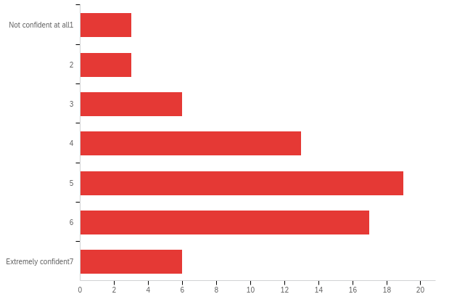

|  |  |  |  |  |  |  |  |
| --- | --- | --- | --- | --- | --- | --- | --- |
| # | Field | Minimum | Maximum | Mean | Std Deviation | Variance | Count |
| 1 | How confident are you that this answer is at least approximately correct? | 1.00 | 8.00 | 4.84 | 1.64 | 2.70 | 67 |

|  |  |  |  |
| --- | --- | --- | --- |
| # | Answer | % | Count |
| 1 | Not confident at all 1 | 4.48% | 3 |
| 2 | 2 | 4.48% | 3 |
| 3 | 3 | 8.96% | 6 |
| 4 | 4 | 19.40% | 13 |
| 5 | 5 | 28.36% | 19 |
| 6 | 6 | 25.37% | 17 |
| 8 | Extremely confident 7 | 8.96% | 6 |
|  | Total | 100% | 67 |

**conv_small_comp_a - On average, how good do you think these players are at the game?**

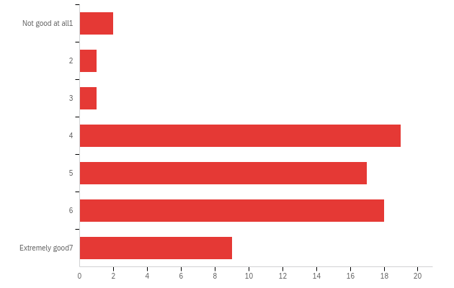

|  |  |  |  |  |  |  |  |
| --- | --- | --- | --- | --- | --- | --- | --- |
| # | Field | Minimum | Maximum | Mean | Std Deviation | Variance | Count |
| 1 | On average, how good do you think these players are at the game? | 1.00 | 8.00 | 5.19 | 1.55 | 2.40 | 67 |

|  |  |  |  |
| --- | --- | --- | --- |
| # | Answer | % | Count |
| 1 | Not good at all 1 | 2.99% | 2 |
| 2 | 2 | 1.49% | 1 |
| 3 | 3 | 1.49% | 1 |
| 4 | 4 | 28.36% | 19 |
| 5 | 5 | 25.37% | 17 |
| 6 | 6 | 26.87% | 18 |
| 8 | Extremely good 7 | 13.43% | 9 |
|  | Total | 100% | 67 |

**conv_small_guess_b - What would you guess is the correct answer, if there is one?**

|  |  |  |  |  |  |  |  |
| --- | --- | --- | --- | --- | --- | --- | --- |
| # | Field | Minimum | Maximum | Mean | Std Deviation | Variance | Count |
| 1 | 1 | 1251.00 | 1625.00 | 1516.18 | 47.67 | 2272.65 | 67 |

**conv_small_conf_b - How confident are you that this answer is at least approximately correct?**

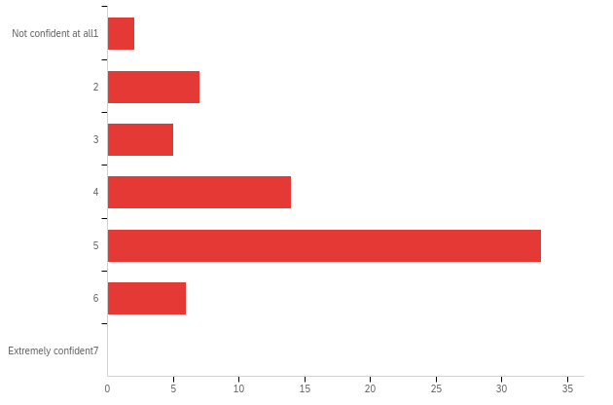

|  |  |  |  |  |  |  |  |
| --- | --- | --- | --- | --- | --- | --- | --- |
| # | Field | Minimum | Maximum | Mean | Std Deviation | Variance | Count |
| 1 | How confident are you that this answer is at least approximately correct? | 1.00 | 6.00 | 4.30 | 1.23 | 1.52 | 67 |

|  |  |  |  |
| --- | --- | --- | --- |
| # | Answer | % | Count |
| 1 | Not confident at all 1 | 2.99% | 2 |
| 2 | 2 | 10.45% | 7 |
| 3 | 3 | 7.46% | 5 |
| 4 | 4 | 20.90% | 14 |
| 5 | 5 | 49.25% | 33 |
| 6 | 6 | 8.96% | 6 |
| 8 | Extremely confident 7 | 0.00% | 0 |
|  | Total | 100% | 67 |

**conv_small_comp_b - On average, how good do you think these players are at the game?**

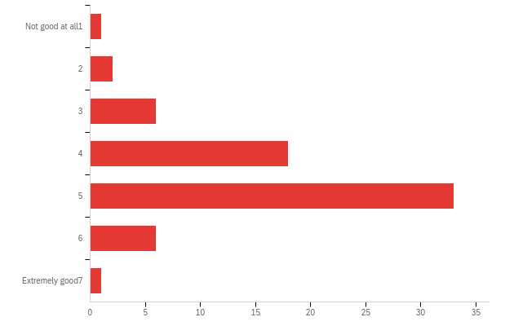

|  |  |  |  |  |  |  |  |
| --- | --- | --- | --- | --- | --- | --- | --- |
| # | Field | Minimum | Maximum | Mean | Std Deviation | Variance | Count |
| 1 | On average, how good do you think these players are at the game? | 1.00 | 8.00 | 4.54 | 1.07 | 1.14 | 67 |

|  |  |  |  |
| --- | --- | --- | --- |
| # | Answer | % | Count |
| 1 | Not good at all 1 | 1.49% | 1 |
| 2 | 2 | 2.99% | 2 |
| 3 | 3 | 8.96% | 6 |
| 4 | 4 | 26.87% | 18 |
| 5 | 5 | 49.25% | 33 |
| 6 | 6 | 8.96% | 6 |
| 8 | Extremely good 7 | 1.49% | 1 |
|  | Total | 100% | 67 |

**noconv_large_guess_a - What would you guess is the correct answer, if there is one?**

|  |  |  |  |  |  |  |  |
| --- | --- | --- | --- | --- | --- | --- | --- |
| # | Field | Minimum | Maximum | Mean | Std Deviation | Variance | Count |
| 1 | 1 | 1139.00 | 1676.00 | 1495.28 | 102.86 | 10579.28 | 67 |

**noconv_large_conf_a - How confident are you that this answer is at least approximately correct?**

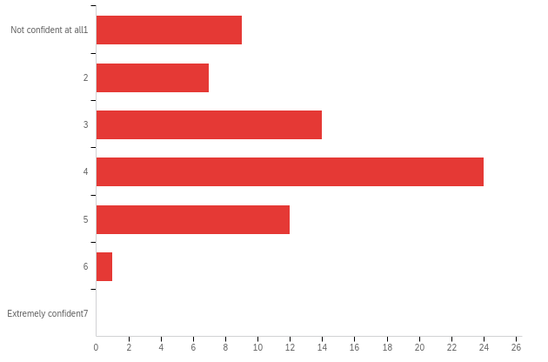

|  |  |  |  |  |  |  |  |
| --- | --- | --- | --- | --- | --- | --- | --- |
| # | Field | Minimum | Maximum | Mean | Std Deviation | Variance | Count |
| 1 | How confident are you that this answer is at least approximately correct? | 1.00 | 6.00 | 3.39 | 1.30 | 1.70 | 67 |

|  |  |  |  |
| --- | --- | --- | --- |
| # | Answer | % | Count |
| 1 | Not confident at all 1 | 13.43% | 9 |
| 2 | 2 | 10.45% | 7 |
| 3 | 3 | 20.90% | 14 |
| 4 | 4 | 35.82% | 24 |
| 5 | 5 | 17.91% | 12 |
| 6 | 6 | 1.49% | 1 |
| 8 | Extremely confident 7 | 0.00% | 0 |
|  | Total | 100% | 67 |

**noconv_large_comp_a - On average, how good do you think these players are at the game?**

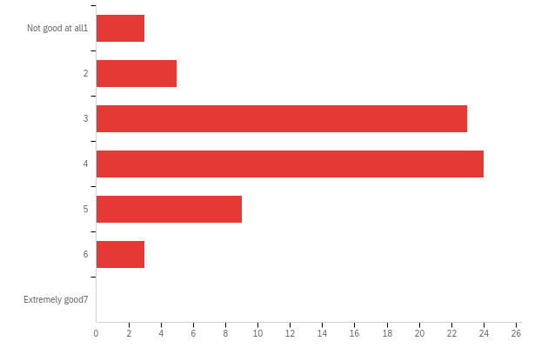

|  |  |  |  |  |  |  |  |
| --- | --- | --- | --- | --- | --- | --- | --- |
| # | Field | Minimum | Maximum | Mean | Std Deviation | Variance | Count |
| 1 | On average, how good do you think these players are at the game? | 1.00 | 6.00 | 3.60 | 1.09 | 1.20 | 67 |

|  |  |  |  |
| --- | --- | --- | --- |
| # | Answer | % | Count |
| 1 | Not good at all 1 | 4.48% | 3 |
| 2 | 2 | 7.46% | 5 |
| 3 | 3 | 34.33% | 23 |
| 4 | 4 | 35.82% | 24 |
| 5 | 5 | 13.43% | 9 |
| 6 | 6 | 4.48% | 3 |
| 8 | Extremely good 7 | 0.00% | 0 |
|  | Total | 100% | 67 |

**noconv_large_guess_b - What would you guess is the correct answer, if there is one?**

|  |  |  |  |  |  |  |  |
| --- | --- | --- | --- | --- | --- | --- | --- |
| # | Field | Minimum | Maximum | Mean | Std Deviation | Variance | Count |
| 1 | 1 | 1244.00 | 1835.00 | 1612.09 | 73.48 | 5399.78 | 67 |

**noconv_large_conf_b - How confident are you that this answer is at least approximately correct?**

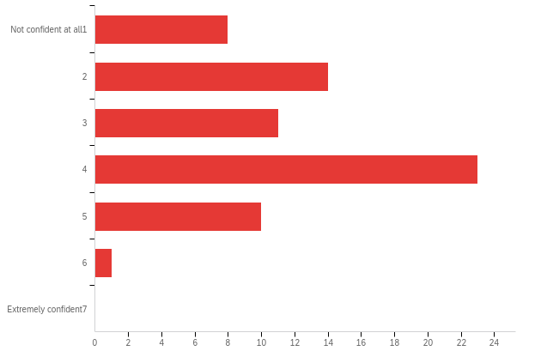

|  |  |  |  |  |  |  |  |
| --- | --- | --- | --- | --- | --- | --- | --- |
| # | Field | Minimum | Maximum | Mean | Std Deviation | Variance | Count |
| 1 | How confident are you that this answer is at least approximately correct? | 1.00 | 6.00 | 3.24 | 1.31 | 1.70 | 67 |

|  |  |  |  |
| --- | --- | --- | --- |
| # | Answer | % | Count |
| 1 | Not confident at all 1 | 11.94% | 8 |
| 2 | 2 | 20.90% | 14 |
| 3 | 3 | 16.42% | 11 |
| 4 | 4 | 34.33% | 23 |
| 5 | 5 | 14.93% | 10 |
| 6 | 6 | 1.49% | 1 |
| 8 | Extremely confident 7 | 0.00% | 0 |
|  | Total | 100% | 67 |

**noconv_large_comp_b - On average, how good do you think these players are at the game?**

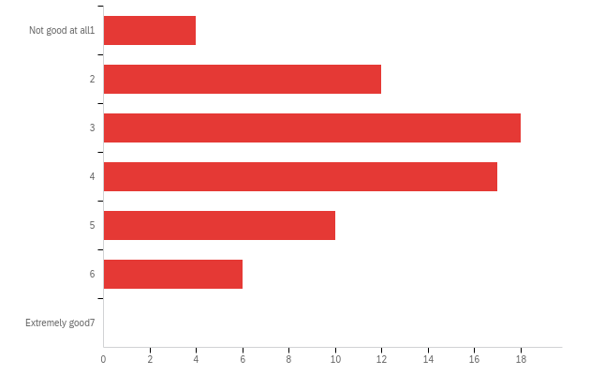

|  |  |  |  |  |  |  |  |
| --- | --- | --- | --- | --- | --- | --- | --- |
| # | Field | Minimum | Maximum | Mean | Std Deviation | Variance | Count |
| 1 | On average, how good do you think these players are at the game? | 1.00 | 6.00 | 3.52 | 1.34 | 1.80 | 67 |

|  |  |  |  |
| --- | --- | --- | --- |
| # | Answer | % | Count |
| 1 | Not good at all 1 | 5.97% | 4 |
| 2 | 2 | 17.91% | 12 |
| 3 | 3 | 26.87% | 18 |
| 4 | 4 | 25.37% | 17 |
| 5 | 5 | 14.93% | 10 |
| 6 | 6 | 8.96% | 6 |
| 8 | Extremely good 7 | 0.00% | 0 |
|  | Total | 100% | 67 |

**noconv_small_guess_a - What would you guess is the correct answer, if there is one?**

|  |  |  |  |  |  |  |  |
| --- | --- | --- | --- | --- | --- | --- | --- |
| # | Field | Minimum | Maximum | Mean | Std Deviation | Variance | Count |
| 1 | 1 | 1248.00 | 1759.00 | 1483.18 | 58.58 | 3431.22 | 67 |

**noconv_small_conf_a - How confident are you that this answer is at least approximately correct?**

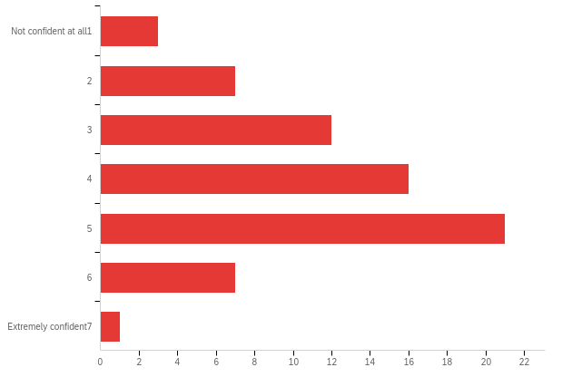

|  |  |  |  |  |  |  |  |
| --- | --- | --- | --- | --- | --- | --- | --- |
| # | Field | Minimum | Maximum | Mean | Std Deviation | Variance | Count |
| 1 | How confident are you that this answer is at least approximately correct? | 1.00 | 8.00 | 4.06 | 1.40 | 1.97 | 67 |

|  |  |  |  |
| --- | --- | --- | --- |
| # | Answer | % | Count |
| 1 | Not confident at all 1 | 4.48% | 3 |
| 2 | 2 | 10.45% | 7 |
| 3 | 3 | 17.91% | 12 |
| 4 | 4 | 23.88% | 16 |
| 5 | 5 | 31.34% | 21 |
| 6 | 6 | 10.45% | 7 |
| 8 | Extremely confident 7 | 1.49% | 1 |
|  | Total | 100% | 67 |

**noconv_small_comp_a - On average, how good do you think these players are at the game?**

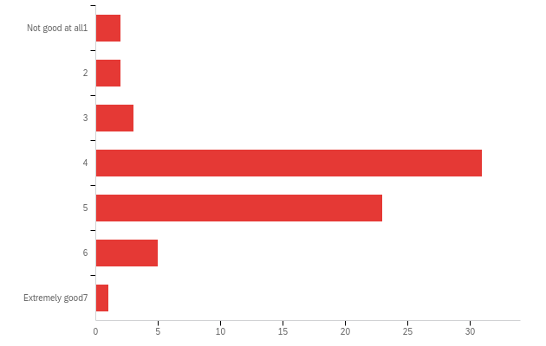

|  |  |  |  |  |  |  |  |
| --- | --- | --- | --- | --- | --- | --- | --- |
| # | Field | Minimum | Maximum | Mean | Std Deviation | Variance | Count |
| 1 | On average, how good do you think these players are at the game? | 1.00 | 8.00 | 4.36 | 1.09 | 1.19 | 67 |

|  |  |  |  |
| --- | --- | --- | --- |
| # | Answer | % | Count |
| 1 | Not good at all 1 | 2.99% | 2 |
| 2 | 2 | 2.99% | 2 |
| 3 | 3 | 4.48% | 3 |
| 4 | 4 | 46.27% | 31 |
| 5 | 5 | 34.33% | 23 |
| 6 | 6 | 7.46% | 5 |
| 8 | Extremely good 7 | 1.49% | 1 |
|  | Total | 100% | 67 |

**noconv_small_guess_b - What would you guess is the correct answer, if there is one?**

|  |  |  |  |  |  |  |  |
| --- | --- | --- | --- | --- | --- | --- | --- |
| # | Field | Minimum | Maximum | Mean | Std Deviation | Variance | Count |
| 1 | 1 | 1090.00 | 1728.00 | 1357.64 | 97.89 | 9582.26 | 67 |

**noconv_small_conf_b - How confident are you that this answer is at least approximately correct?**

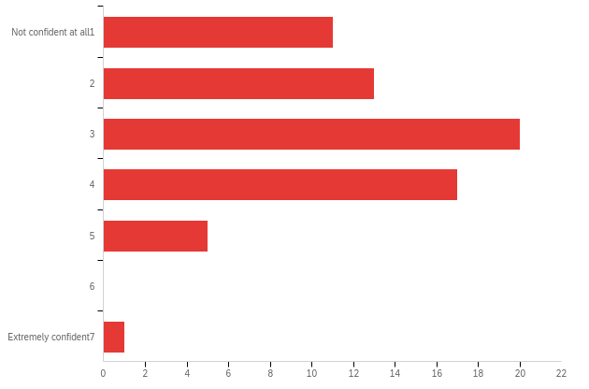

|  |  |  |  |  |  |  |  |
| --- | --- | --- | --- | --- | --- | --- | --- |
| # | Field | Minimum | Maximum | Mean | Std Deviation | Variance | Count |
| 1 | How confident are you that this answer is at least approximately correct? | 1.00 | 8.00 | 2.96 | 1.33 | 1.77 | 67 |

|  |  |  |  |
| --- | --- | --- | --- |
| # | Answer | % | Count |
| 1 | Not confident at all 1 | 16.42% | 11 |
| 2 | 2 | 19.40% | 13 |
| 3 | 3 | 29.85% | 20 |
| 4 | 4 | 25.37% | 17 |
| 5 | 5 | 7.46% | 5 |
| 6 | 6 | 0.00% | 0 |
| 8 | Extremely confident 7 | 1.49% | 1 |
|  | Total | 100% | 67 |

**noconv_small_comp_b - On average, how good do you think these players are at the game?**

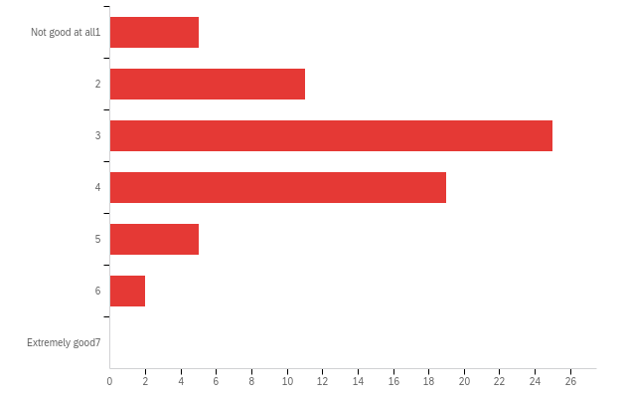

|  |  |  |  |  |  |  |  |
| --- | --- | --- | --- | --- | --- | --- | --- |
| # | Field | Minimum | Maximum | Mean | Std Deviation | Variance | Count |
| 1 | On average, how good do you think these players are at the game? | 1.00 | 6.00 | 3.21 | 1.13 | 1.27 | 67 |

|  |  |  |  |
| --- | --- | --- | --- |
| # | Answer | % | Count |
| 1 | Not good at all 1 | 7.46% | 5 |
| 2 | 2 | 16.42% | 11 |
| 3 | 3 | 37.31% | 25 |
| 4 | 4 | 28.36% | 19 |
| 5 | 5 | 7.46% | 5 |
| 6 | 6 | 2.99% | 2 |
| 8 | Extremely good 7 | 0.00% | 0 |
|  | Total | 100% | 67 |

**Q2 - Before finishing, please provide the following information. Once you are done with these questions, please do not forget to press the arrow to complete the survey and get your completion code.**



|  |  |  |  |  |  |  |  |
| --- | --- | --- | --- | --- | --- | --- | --- |
| # | Field | Minimum | Maximum | Mean | Std Deviation | Variance | Count |
| 1 | Before finishing, please provide the following information. Once you are done with these questions, please do not forget to press the arrow to complete the survey and get your completion code. | 0.00 | 0.00 | 0.00 | 0.00 | 0.00 | 0 |

|  |  |  |
| --- | --- | --- |
| Answer | % | Count |
| Total |  | undefined |

**Q3 - What is your gender?**

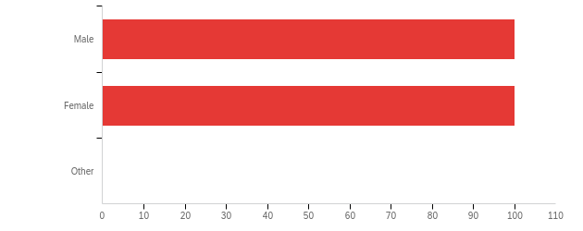

|  |  |  |  |  |  |  |  |
| --- | --- | --- | --- | --- | --- | --- | --- |
| # | Field | Minimum | Maximum | Mean | Std Deviation | Variance | Count |
| 1 | What is your gender? | 1.00 | 2.00 | 1.50 | 0.50 | 0.25 | 200 |

|  |  |  |  |
| --- | --- | --- | --- |
| # | Answer | % | Count |
| 1 | Male | 50.00% | 100 |
| 2 | Female | 50.00% | 100 |
| 3 | Other | 0.00% | 0 |
|  | Total | 100% | 200 |

**Q4 - What is your age?**

|  |
| --- |
| What is your age? |
| 21 |
| 56 |
| 35 |
| 38 |
| 38 |
| 65 |
| 65 |
| 52 |
| 32 |
| 34 |
| 48 |
| 39 |
| 28 |
| 62 |
| 53 |
| 25 |
| 40 |
| 44 |
| 45 |
| 69 |
| 63 |
| 59 |
| 58 |
| 23 |
| 45 |
| 32 |
| 58 |
| 26 |
| 20 |
| 34 |
| 28 |
| 23 |
| 22 |
| 23 |
| 49 |
| 66 |
| 25 |
| 57 |
| 24 |
| 58 |
| 34 |
| 60 |
| 42 |
| 20 |
| 30 |
| 21 |
| 38 |
| 58 |
| 52 |
| 27 |
| 70 |
| 49 |
| 50 |
| 29 |
| 36 |
| 21 |
| 56 |
| 37 |
| 21 |
| 31 |
| 75 |
| 24 |
| 23 |
| 42 |
| 69 |
| 23 |
| 57 |
| 79 |
| 33 |
| 59 |
| 32 |
| 37 |
| 30 |
| 36 |
| 63 |
| 29 |
| 19 |
| 37 |
| 51 |
| 20 |
| 34 |
| 60 |
| 39 |
| 29 |
| 50 |
| 46 |
| 32 |
| 21 |
| 58 |
| 33 |
| 27 |
| 27 |
| 31 |
| 20 |
| 63 |
| 28 |
| 37 |
| 56 |
| 19 |
| 63 |
| 38 |
| 39 |
| 55 |
| 45 |
| 67 |
| 63 |
| 36 |
| 31 |
| 42 |
| 19 |
| 34 |
| 72 |
| 62 |
| 41 |
| 36 |
| 43 |
| 65 |
| 24 |
| 52 |
| 68 |
| 60 |
| 46 |
| 42 |
| 37 |
| 30 |
| 29 |
| 29 |
| 53 |
| 31 |
| 28 |
| 30 |
| 29 |
| 39 |
| 19 |
| 23 |
| 64 |
| 40 |
| 25 |
| 19 |
| 21 |
| 66 |
| 32 |
| 61 |
| 46 |
| 19 |
| 23 |
| 25 |
| 25 |
| 29 |
| 47 |
| 33 |
| 31 |
| 33 |
| 19 |
| 59 |
| 59 |
| 36 |
| 65 |
| 29 |
| 26 |
| 30 |
| 58 |
| 30 |
| 24 |
| 51 |
| 26 |
| 25 |
| 27 |
| 18 |
| 58 |
| 54 |
| 26 |
| 28 |
| 28 |
| 59 |
| 69 |
| 21 |
| 23 |
| 35 |
| 34 |
| 26 |
| 45 |
| 25 |
| 32 |
| 49 |
| 39 |
| 22 |
| 52 |
| 61 |
| 53 |
| 51 |
| 66 |
| 21 |
| 33 |
| 33 |
| 32 |
| 29 |
| 24 |
| 34 |
| 31 |

**Q5 - What is the highest level of education you have completed?**

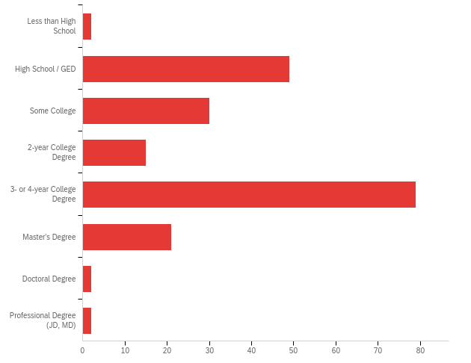

|  |  |  |  |  |  |  |  |
| --- | --- | --- | --- | --- | --- | --- | --- |
| # | Field | Minimum | Maximum | Mean | Std Deviation | Variance | Count |
| 1 | What is the highest level of education you have completed? | 1.00 | 8.00 | 4.00 | 1.51 | 2.28 | 200 |

|  |  |  |  |
| --- | --- | --- | --- |
| # | Answer | % | Count |
| 1 | Less than High School | 1.00% | 2 |
| 2 | High School / GED | 24.50% | 49 |
| 3 | Some College | 15.00% | 30 |
| 4 | 2-year College Degree | 7.50% | 15 |
| 5 | 3- or 4-year College Degree | 39.50% | 79 |
| 6 | Master's Degree | 10.50% | 21 |
| 7 | Doctoral Degree | 1.00% | 2 |
| 8 | Professional Degree (JD, MD) | 1.00% | 2 |
|  | Total | 100% | 200 |

**PROLIFIC_PID**

|  |
| --- |
| PROLIFIC_PID |
| 5eb151cc6e76f820eb3a330b |
| 5ecd22e76997ec03464c71aa |
| 5f3a9a262fd4896cfdf870a8 |
| 60ccc83bea0576d2f30da90b |
| 5aa7e3a66475f90001a06f7e |
| 5f9eb2b4530d3e45e450e42e |
| 575eab31862b0f0006cd7dec |
| 6156fef1e85e93bd92ba45ee |
| 5a847fd2aa46dd00016ba03c |
| 59655329a670a10001942540 |
| 5c463bc8b05faa0001d62716 |
| 5ea6eba9aba41b078b6a832f |
| 5e2a2b0f3d25b70994890969 |
| 622a6dc874038359001a9e95 |
| 60264f219516732a1dc72394 |
| 6123a6a7ecf260c2a9b25733 |
| 60c71db92651d246c6081107 |
| 611641c6583d8bab5012dee0 |
| 5ddd9d0e40460ecfff653cb5 |
| 5abf047d1667e40001d82e45 |
| 5eac70db94edd22d57fa00c4 |
| 5ddba1b941fb3fae60ceb0c3 |
| 5ee935230c3e3f2c25f6f83a |
| 5e8ea111f5166b1680ef8eef |
| 5d92145df583b100181423db |
| 5b5477c2329be10001938ff8 |
| 5bc5be2572df5f00014479f9 |
| 5c86303fc2ceec001719a6eb |
| 5c7fb04093cdce00160adf49 |
| 61f2adcea09e72f23cbaf96a |
| 5ad2254db438910001ac9c31 |
| 5f53b73f18bf9a6ed513ca61 |
| 61486b40198550b29e7f29be |
| 5f6f24f71b1cd746e9ded65e |
| 5ea18fb96205ad04eae7342c |
| 59a5fd55145f7000017ab7e3 |
| 5ffc8b3359c0d0096cc8e234 |
| 5cd942fdcc98b20019852b50 |
| 5eb84ddb1aa1b479b631a1fb |
| 5aead25562ac0e00010974b1 |
| 5ee60e6af4d9c0366af53a7f |
| 5d1b7ca2ebfae6001a9e4401 |
| 60435c1d1d1a6f2effcfb8f1 |
| 610af1f010f5e9cb15989d31 |
| 615f42ca58f6e800db5a9821 |
| 5e9b9eaee0e30b0b27983c50 |
| 5ed0dc47fd66121c75e88443 |
| 5db7203e98ecdf000ae8d504 |
| 5c65e8114f67dc0001542266 |
| 5a9ed3f26219a30001f54e85 |
| 59e8a9b1d838ae0001850c89 |
| 5f09fab615ee6b0ab5235b15 |
| 601c141abca398678a72ff4c |
| 5dcf1031b039ab061db5243e |
| 5ac499001667e40001d859f9 |
| 5d352f8bb02857001963539a |
| 56278536ddff3c0005bcdad9 |
| 5e737c034da556000ac9d606 |
| 6026e1c91fcd140c25ec6076 |
| 60b4ae00a553ce01ecec6699 |
| 5ed8f853923c0941e1238299 |
| 5e570f6b38fb3a0d3c15e266 |
| 5cfbef1b50597d0001e8f11e |
| 5ee013785a5719357e9ce0cf |
| 577f91b84d107800016d9e69 |
| 5ed00b67157bd20c24f3fc51 |
| 59e4fe99c0d35a0001294f8b |
| 5c6e591fc114eb00018b2633 |
| 60858fa033677878a8399e3a |
| 5ea4115637284839f59110e1 |
| 5bab5f23fdc48b00017769b7 |
| 5afd6d5b56fe2c0001690178 |
| 5dbecb5e30c4d737494efe10 |
| 5be6f1cbeca90b0001e6e8d5 |
| 5a678d0bb9e3b50001a73fa3 |
| 5b1a88970ada0a0001e0f483 |
| 60d370d873117813ba043af5 |
| 5ea596f614912a579c4e52e1 |
| 59b57bccd98aab00019bb1a3 |
| 5fcd1c5584c8d416c797d96a |
| 60c33f3e6706eca45e689ea4 |
| 6167116fd8a186cd98501614 |
| 602db1b6986cfd292b134d4c |
| 5f76303f951dda087d02e0bc |
| 5f64ea0392e24101c0bfaebe |
| 5efad067339562914d784503 |
| 5e0f189d4c81b262eb326f2e |
| 5f51114394f9472e53bc5936 |
| 589cb50d4d580c0001e09d16 |
| 6169d51314e3d1b78a88caf1 |
| 60882005bba3d0951e32e1b8 |
| 612d1746a8d65bea189cd548 |
| 5f24a699b63d070b1fbc0619 |
| 5fd3fc5121ea1c140bf4a272 |
| 60f5569b3a95a18a91dc5d21 |
| 617285bcc61b22a31210faa3 |
| 5fad74db5cdcd70beb72b777 |
| 5cdd4befd3651c001950e539 |
| 5f05e24314e7c90bb6b43cc8 |
| 57e131b80cb6700001dd7e5c |
| 588126f90234ec00016eff60 |
| 61656be3235b845792b267ba |
| 5dab89f4e9adfe00173caa73 |
| 5fa951617709a108aeddcd53 |
| 5eea37b60e95520ef6907500 |
| 5bfa91cf26e31d00010462ed |
| 5be87656822047000181d875 |
| 5ec6c8ad6f911e0e87e58b1f |
| 60c347136d0a78b90bbd88e6 |
| 616823f4aacb6e9b1cde751c |
| 5981b3289bf4fe0001070aea |
| 5efb18d8ef19f5029af663a5 |
| 5c8ce2f39d2bff0001b3fcea |
| 5c2004c3da51990001e165b2 |
| 5da855e8db29f000128d738a |
| 5b27b81293707800011eabdd |
| 5cb7be4c30e566001a8b04b5 |
| 5eeb9854ef20d70e582acebd |
| 59205fcb97a88c000145d191 |
| 5f088147510abc0947ad09cb |
| 54847094fdf99b0379939c8e |
| 5c9b534b519f7500182be9b7 |
| 614721cb6d8ce56e9e7aff9d |
| 6060dcaf19b714b145f5a5f3 |
| 5b74960f218c0f000107d480 |
| 5c2e5db32c45d400014a9b4e |
| 592a232ed13ea60001553e51 |
| 611f6757f935f97babc092c5 |
| 5e19b6135bcd432316ad611d |
| 6058d2405f4008ae73478bd5 |
| 610d44c612fa08637162fbd0 |
| 5cc4509c2daae1001987e95b |
| 5c61598fb40f380001109ca5 |
| 61670802a36d216563a5bd60 |
| 5b92bd88f2ac7e0001d8a45f |
| 56864f2f333cbd000c4e4db6 |
| 59bad6a60ac77f0001f05254 |
| 5f7b18a04caba9049fd3283a |
| 6106919acfdc82263f1297d9 |
| 5eff26cb359bc645ec530cbb |
| 5f57fd0328b04b3489d452e9 |
| 5e23175dd84c1b5ca13b1cd0 |
| 6125067aa09e6b144c8ec8b6 |
| 5e285f486167be038c5c0a49 |
| 5eb4841544c2df2f0190e8a0 |
| 5cf9c2d6dfcf0a0015e8e213 |
| 5f751715d7804519031aa4f2 |
| 5fc8f86079e4a6306ef1616e |
| 5e072bb71d6b460b5e6eae99 |
| 5f562fc05e6f8a000965cbd5 |
| 5d78cb8a44b0d10001a53485 |
| 60b7f102c27f0b693919fc98 |
| 5784d25070c76a00012427e0 |
| 5f1c62b6554a0f4f129c75fd |
| 5ce43a70aade7100152e6e77 |
| 56a7da16c89737000b22953c |
| 5e550321537ed2000b1e5ad2 |
| 5c472ac67379d8000112983d |
| 591c58daa940aa0001f1bd8f |
| 5b846cdbcecee70001351e21 |
| 5d4934304c12d50015ec3e1f |
| 5db92f4d8e9761000d7d7a8b |
| 5d5357e0b45aff0001980d13 |
| 614ef5b48e102069659031ba |
| 5a7094c4f660ae0001a98bd5 |
| 5ecc2a43543cc180222321d3 |
| 5f60abca7aa062068858abaf |
| 60fd0fdd7e3e57ca7d5182f1 |
| 60bd0b154d2a4347a66b551e |
| 5e59982929132107a864c783 |
| 5978c32bcae3340001134a46 |
| 6140e3be2e0c5456ad63dbdd |
| 5f0f4a855137200d21e1befe |
| 5c865d87d6a29e00172eefb4 |
| 5680452cc5767f00121cc81a |
| 5ea133c68d67911401c2ea57 |
| 5e53f975e61d06022f73e241 |
| 5ec3eabec8f93307a60c5d1b |
| 5958dfbc8c7f1a00013bd0b9 |
| 5a238241a7788f000144aca2 |
| 5fe1f5f751f3a9ceb57d935a |
| 5cdef91bf4acd700153ac9db |
| 5e32f669641109012e2a0531 |
| 5f62521ef07ba314e1e297d6 |
| 5fe0f4a8e6b281af7dd9de1a |
| 5eb1614dfff7a624f18e62be |
| 603acc04f7671274214e49b2 |
| 5ea048ef3427cf06b692b9d4 |
| 5953acc10dd7710001aec19e |
| 614f9daff9b7bf1a0f4c4f9c |
| 600a878fa6fbbf1ba60bea36 |
| 5bbfa1a41ff4ba00011c330b |
| 5becb1e76a75a100010b7f75 |
| 56e1bb4e6ce054000b3ffcaf |
| 5e15047894d5eeb157532e7f |
| 611107eaa48093e17e7e56d2 |
| 5d548c047795f80001bf611f |
| 5f14a3b0188dff519298a4c6 |
| 5ae7107c3b85e70001176dd4 |
| 61673c4003922ad28160efdd |

**counter**

|  |
| --- |
| counter |
| 8 |
| 8 |
| 8 |
| 8 |
| 8 |
| 8 |
| 8 |
| 8 |
| 8 |
| 8 |
| 8 |
| 8 |
| 8 |
| 8 |
| 8 |
| 8 |
| 8 |
| 8 |
| 8 |
| 8 |
| 8 |
| 8 |
| 8 |
| 8 |
| 8 |
| 8 |
| 8 |
| 8 |
| 8 |
| 8 |
| 8 |
| 8 |
| 8 |
| 8 |
| 8 |
| 8 |
| 8 |
| 8 |
| 8 |
| 8 |
| 8 |
| 8 |
| 8 |
| 8 |
| 8 |
| 8 |
| 8 |
| 8 |
| 8 |
| 8 |
| 8 |
| 8 |
| 8 |
| 8 |
| 8 |
| 8 |
| 8 |
| 8 |
| 8 |
| 8 |
| 8 |
| 8 |
| 8 |
| 8 |
| 8 |
| 8 |
| 8 |
| 8 |
| 8 |
| 8 |
| 8 |
| 8 |
| 8 |
| 8 |
| 8 |
| 8 |
| 8 |
| 8 |
| 8 |
| 8 |
| 8 |
| 8 |
| 8 |
| 8 |
| 8 |
| 8 |
| 8 |
| 8 |
| 8 |
| 8 |
| 8 |
| 8 |
| 8 |
| 8 |
| 8 |
| 8 |
| 8 |
| 8 |
| 8 |
| 8 |
| 8 |
| 8 |
| 8 |
| 8 |
| 8 |
| 8 |
| 8 |
| 8 |
| 8 |
| 8 |
| 8 |
| 8 |
| 8 |
| 8 |
| 8 |
| 8 |
| 8 |
| 8 |
| 8 |
| 8 |
| 8 |
| 8 |
| 8 |
| 8 |
| 8 |
| 8 |
| 8 |
| 8 |
| 8 |
| 8 |
| 8 |
| 8 |
| 8 |
| 8 |
| 8 |
| 8 |
| 8 |
| 8 |
| 8 |
| 8 |
| 8 |
| 8 |
| 8 |
| 8 |
| 8 |
| 8 |
| 8 |
| 8 |
| 8 |
| 8 |
| 8 |
| 8 |
| 8 |
| 8 |
| 8 |
| 8 |
| 8 |
| 8 |
| 8 |
| 8 |
| 8 |
| 8 |
| 8 |
| 8 |
| 8 |
| 8 |
| 8 |
| 8 |
| 8 |
| 8 |
| 8 |
| 8 |
| 8 |
| 8 |
| 8 |
| 8 |
| 8 |
| 8 |
| 8 |
| 8 |
| 8 |
| 8 |
| 8 |
| 8 |
| 8 |
| 8 |
| 8 |
| 8 |
| 8 |
| 8 |
| 8 |
| 8 |
| 8 |
| 8 |
| 8 |
| 8 |
| 8 |
| 8 |
| 8 |
| 8 |